An Integrated Supervised and Unsupervised Machine Learning Framework for Classification and Clinical Pattern Discovery in Musculoskeletal Outpatient Records in Libya

Abubaker Benshatwan¹ , Hasan M Alqatani² , Salema M Nouri³, Siraj M Elgahani ⁴. Fatmah G Hamzah⁵.
¹ ² ³ ⁴ ⁵ Faculty of Computer Technology and Information, Al-Salam International University, , Benghazi, Libya

Abstract -This study aims to employ supervised and unsupervised machine learning to analyze outpatient clinic records for musculoskeletal disorders in Libya. The study relied on real-world clinical data containing structured fields and free clinical text. Three research datasets were derived from the original data: a supervised dataset for classification, an unsupervised pre-diagnosis dataset (PRE), and an unsupervised post-visit dataset (POST). The unsupervised learning results showed that the PRE dataset revealed three broad clinical groups, whereas the POST dataset revealed five more detailed groups. In the supervised learning pathway, LinearSVC achieved the best performance, with an accuracy of 71.96% and a Macro-F1 score of 71.87%. Accuracy further increased to 84.16% when only high-confidence cases were classified. The findings indicate that unsupervised learning is useful for understanding clinical structure, whereas supervised learning provides practical classification capability. However, overlap between clinical categories and low-information clinical texts remain among the main performance challenges.
Keywords: electronic health records, musculoskeletal disorders, supervised learning, unsupervised learning, clustering, Libya.
I. INTRODUCTION
Musculoskeletal disorders are among the most prevalent health problems worldwide. They include a wide range of conditions such as low back pain, neck pain, sciatica, knee osteoarthritis, hip and pelvic disorders, shoulder pain, and chronic myofascial pain. Their impact is not limited to physical pain; it also extends to reduced functional capacity, lower quality of life, frequent medical visits, and increased economic burden on patients and healthcare systems. The World Health Organization identifies musculoskeletal disorders as a major global cause of disability, while the Global Burden of Disease study has shown that low back pain alone represents a substantial health burden that is expected to persist until 2050 (World Health Organization, 2022; GBD 2021 Low Back Pain Collaborators, 2023).
In this context, outpatient clinics represent a rich source of real-world clinical data. They receive large numbers of patients with chronic or recurrent pain and document multiple types of information for each visit, such as age, gender, city, hospital, chief complaint, medical history, surgical history, drug history, diagnosis, treatment plan, and proposed procedures. However, these records are often not ready for direct analysis or modeling because they combine structured variables with short and non-standardized free clinical text. Clinical information may appear in the complaint field, in the diagnosis field, or within a treatment note. It may also be written in English, Arabic, or medical abbreviations.
Recent literature on electronic health records (EHRs) emphasizes that the success of machine learning models in medicine does not depend only on the algorithm. It also depends heavily on data design quality, variable definition, bias prevention, reduction of information leakage, and the distinction between information available before a clinical decision and information generated after it (Tang et al., 2024). This point is especially important in real-world medical studies because using post-diagnosis variables in a model intended to predict before diagnosis may produce apparently high but clinically invalid performance.
Clinical Natural Language Processing has also become a central component in medical record analysis because free-text notes contain clinical information that does not always appear in structured fields. Bazoge et al. (2023) reported that NLP applications in clinical data warehouses include classification, entity extraction, relation extraction, and content analysis. Therefore, clinical text should not be treated as a secondary element; rather, it should be considered a primary source for understanding and digitally representing the patient’s condition.
The importance of this study lies in applying these principles to real outpatient clinic data in Libya. The purpose is not merely to apply a machine learning model to a ready-made dataset, but to build a research framework that begins with redesigning the data itself and ends with two complementary pathways: a supervised pathway for classification and an unsupervised pathway for discovering latent clinical patterns and clusters. This integration gives the study a deeper analytical dimension because it does not only ask: what is the expected category of the case? It also asks: what clinical patterns organize these records in the first place?
Accordingly, this study seeks to present an applied and methodological framework for analyzing musculoskeletal disorders in Libyan outpatient clinics using machine learning, with a focus on free clinical text, feature engineering, multi-class classification, and unsupervised pattern discovery.
II. PROBLEM STATEMENT
The problem addressed by this study is that outpatient clinic records for musculoskeletal disorders contain high clinical value, yet they are not directly suitable for building reliable machine learning models. This problem appears in several major aspects.
First, the original data contain many fields with varying quality. Some fields are highly complete, such as age, city, and hospital, whereas other fields show high levels of missingness, such as pain score, symptom duration, and allergy information. Second, the data rely heavily on short free-text fields, such as chief complaint and medical history. These texts may contain medical abbreviations, mixed language, or different expressions for the same meaning. Third, there is a potential risk of information leakage if post-visit fields, such as final diagnosis and treatment plan, are used to build a model that is intended to predict before diagnosis.
These problems are not merely organizational. They directly contribute to inflated apparent performance and poor generalizability, especially in EHR studies that do not accurately distinguish between what is available before the clinical decision and what results from it. Free-text fields create an additional challenge because the highest clinical value may be stored in natural language rather than in predefined coded fields.
Based on this, the research problem can be formulated as follows: How can a reliable machine learning framework be built to analyze outpatient clinic records for musculoskeletal disorders in Libya, combining supervised classification and unsupervised pattern discovery while addressing clinical text overlap, missing values, and variation in label quality?
III. AIMS AND OBJECTIVES
The study aims to build an integrated analytical framework for employing machine learning in the analysis of outpatient clinic records for musculoskeletal disorders in Libya.
The specific objectives are as follows:
- Build a clean research database derived from real outpatient clinic records.
- Develop a supervised version suitable for training multi-class classification models.
- Develop an unsupervised pre-diagnosis dataset (PRE) to discover early patterns from complaints and clinical history.
- Develop an unsupervised post-visit dataset (POST) to discover clinical patterns after diagnosis, plan, and procedure information become available.
- Evaluate the analytical value of free clinical text in representing patient conditions.
- Compare the results of supervised and unsupervised learning.
- Analyze the impact of data quality and label overlap on model performance.
Provide a framework that can be expanded in future local and clinical EHR studies
IV. RESEARCH CONTRIBUTIONS
This study offers the following contributions:
- A dual machine learning framework combining supervised classification and unsupervised pattern discovery.
- A local analysis of real Libyan outpatient clinical records, a relatively limited area in the local literature.
- The construction of multiple research-ready datasets from the same source: a supervised dataset, a PRE unsupervised dataset, and a POST unsupervised dataset.
- The integration of free clinical text with structured data, including complaint, medical history, surgical history, drug history, age, gender, city, and hospital.
- An interpretive analysis of clusters using KMeans results, figures, top-weighted terms, heatmaps, and dendrograms.
- An analysis of high-confidence classification performance showing that the supervised model is more useful when it classifies only cases in which it has high confidence.
- The identification of performance limitations caused not only by algorithms but also by clinical overlap between categories such as Spine Disorders and Sciatica/Radiculopathy.

V. LITERATURE REVIEW

1. Electronic Health Records and Data Design
Electronic health records have become a major source for medical research because they provide real-world data derived from daily clinical practice. However, using such data in machine learning requires substantial methodological care. Tang et al. (2024) showed that successful EHR studies depend on precise research-question definition, variable control, missing-data handling, bias reduction, and information leakage prevention. This aligns directly with the present study, which began by analyzing the original dataset and then derived different versions according to each research objective.

2. Clinical Natural Language Processing
Free clinical texts are among the most important sources of information in medical records because they contain descriptions of the patient’s condition and often include details that do not appear in structured fields. Bazoge et al. (2023) demonstrated that NLP is now used for classification, entity extraction, content analysis, and relation extraction from clinical data warehouses. In the present study, NLP is important for cleaning chief complaints, medical history, surgical history, and drug history and then converting them into a numerical representation using TF-IDF.

3. Supervised Learning in the Clinical Domain
Multiple studies have focused on using supervised learning to predict clinical events or diagnoses. Choi et al. (2016) introduced Doctor AI for clinical-event prediction using recurrent neural networks. Li et al. (2020) proposed BEHRT, a Transformer-based model for EHR data. Rasmy et al. (2021) developed Med-BERT to benefit from pretrained representations in structured EHR data. Alsentzer et al. (2019) showed that ClinicalBERT improves performance in clinical NLP tasks. These studies indicate that advanced models may be effective, but they usually require large and relatively clean datasets.
In contrast, the current study found that LinearSVC with TF-IDF outperformed XGBoost and ANN. This suggests that linear models remain strong for short clinical texts, especially when the dataset size is moderate and labels are overlapping.

4. Unsupervised Learning and Clinical Pattern Discovery
Unsupervised learning does not aim to predict a predefined class. Instead, it aims to discover the latent structure within the data. Landi et al. (2020) showed that deep patient representation from EHR data can support clinically meaningful patient stratification. De Freitas et al. (2021) also demonstrated that unsupervised embeddings can help construct disease phenotypes without strict manual rules.
These studies support the use of clustering in the present work, particularly because the goal is not limited to classifying cases but also includes understanding the clinical patterns that organize the data. The literature on patient representation learning and phenotyping supports the construction of unsupervised datasets for discovering latent clinical patterns.

5. Artificial Intelligence in Musculoskeletal Disorders
In the musculoskeletal field, Nelson and Arbeeva (2022) emphasized that using machine learning in rheumatic and musculoskeletal diseases requires careful attention to bias and data quality. Mohammed et al. (2024) showed that artificial intelligence applications in orthopaedic diseases are rapidly expanding but still require stronger trustworthiness and methodological rigor. In chronic pain research, Jenssen et al. (2021) showed that most studies focused on classification, whereas applications related to management and treatment remain less mature.
For clinical texts related to low back pain and spine disorders, Bacco et al. (2022) described NLP in this field as promising but still emerging. Vaid et al. (2023) presented a closely related example by using fine-tuned language models to extract musculoskeletal pain characteristics from unstructured clinical notes. These works highlight the importance of the present study because it applies textual analysis and machine learning to real musculoskeletal clinical records.
The research gap is that most previous studies tend to follow one of two directions: either building a supervised classification model or conducting unsupervised analysis for pattern discovery. Studies that combine both pathways within a single framework and apply them to real mixed-language outpatient clinical data are less common. In addition, Arabic and local literature on applying machine learning to musculoskeletal disorders remains limited. Therefore, the present study attempts to bridge this gap through a framework that combines classification, clustering, text analysis, and data engineering.

VI. PROPOSED METHODOLOGY
The study adopted a multi-path experimental design. The analysis began with the original raw dataset, from which three datasets were derived: a supervised dataset for classification, an unsupervised pre-diagnosis dataset, and an unsupervised post-visit dataset. The pre-diagnosis dataset was used to understand early patterns based on complaint and clinical history. The post-visit dataset was used to understand clinical structure after diagnosis, plan, and procedure information became available. The supervised dataset was used to train classification models.
Table 1. Summary of the datasets used in the study
Dataset | Type | Rows | Columns | Purpose
Daily clinics | Original raw | 3560 | 46 | Primary source
Supervised strict | Supervised | 2656 | 10 | Classification
Pre-diagnosis independent | Unsupervised pre-diagnosis | 3535 | 50 | Early patterns
Post-visit independent | Unsupervised post-visit | 3551 | 68 | Post-visit patterns

Table 2. Completeness of key columns in the original dataset

Column | Completeness
Hospital | 99.83%
Name | 99.80%
Age | 98.26%
City | 99.24%
Phone | 96.74%
Date | 96.40%
Complaint | 94.69%
Medical history | 92.02%
Surgical history | 76.52%
Drug history | 59.86%
Pain scale out of 10 | 15.11%
duration | 15.48%
Procedure - advice - invx | 83.57%
O/E & Diagnosis | 88.06%
Plan | 82.61%
medication | 91.10%
Follow Up | 23.74%
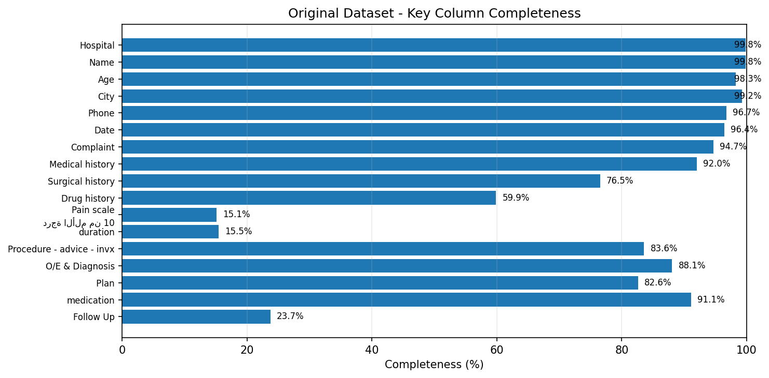
Figure 1. Completeness of key columns in the original dataset.

1. Supervised Dataset
The supervised dataset was built to be suitable for multi-class classification. Therefore, it retained only the fields logically available before final diagnosis and excluded diagnosis, plan, and procedure fields in order to reduce information leakage. This dataset contains 2656 records and 10 columns.
Table 3. Columns of the supervised dataset and their purpose

Column | Description
record_id | Record identifier
hospital | Hospital or clinic
city | City
gender | Gender
age | Age
complaint_clean | Cleaned complaint
medical_history | Medical history
surgical_history | Surgical history
drug_history | Drug history
target_class | Target clinical class

Table 4. Class distribution in the supervised dataset

Class | Count | Percentage
Spine Disorders | 844 | 31.78%
Sciatica/Radiculopathy | 821 | 30.91%
Knee/OA Disorders | 585 | 22.03%
SIJ/Hip Disorders | 406 | 15.29%

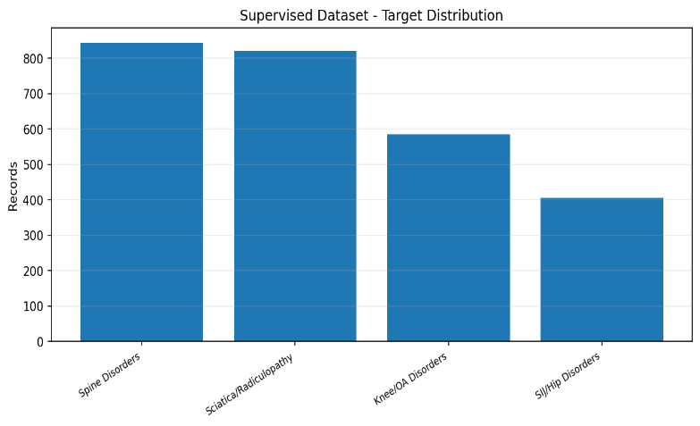
Figure 2. Class distribution in the supervised dataset.

2. Unsupervised Pre-Diagnosis Dataset
The pre-diagnosis dataset was designed to discover patterns before diagnosis. It consists of 3535 records and 50 columns. It relies on complaint, medical history, surgical history, and drug history, in addition to derived features such as age_group, clinical_text_pre_norm, history_burden_score, text_word_count, and clinical indicators such as flag_spine, flag_sciatica, flag_knee, and flag_hip_sij.
Table 5. Characteristics of the unsupervised pre-diagnosis dataset
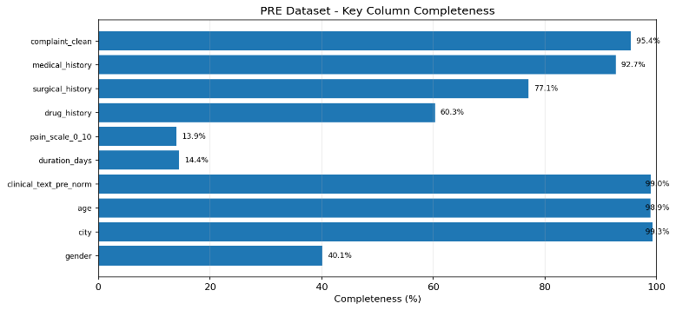
Column | Completeness
complaint_clean | 95.36%
medical_history | 92.67%
surgical_history | 77.06%
drug_history | 60.28%
pain_scale_0_10 | 13.95%
duration_days | 14.43%
clinical_text_pre_norm | 98.95%
age | 98.90%
city | 99.35%
gender | 40.08%
Figure 3. Completeness of key columns in the pre-diagnosis dataset.
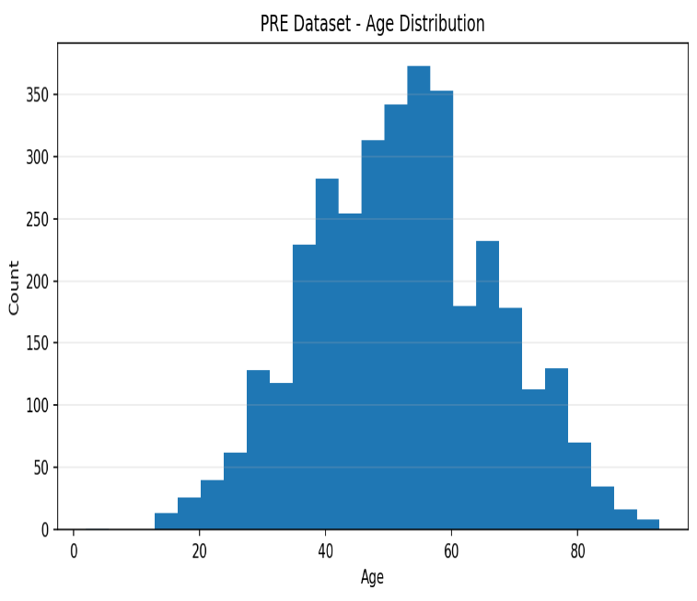
Figure 4. Age distribution in the pre-diagnosis dataset.

Feature | Prevalence
flag_spine | 58.90%
flag_sciatica | 39.29%
flag_knee | 21.02%
flag_hip_sij | 4.47%
flag_lower_limb | 49.84%
flag_upper_limb | 23.51%
flag_diabetes | 24.67%
flag_hypertension | 26.48%
flag_numbness | 19.69%
flag_weakness | 1.30%
flag_radiation | 1.47%
flag_trigger | 2.12%
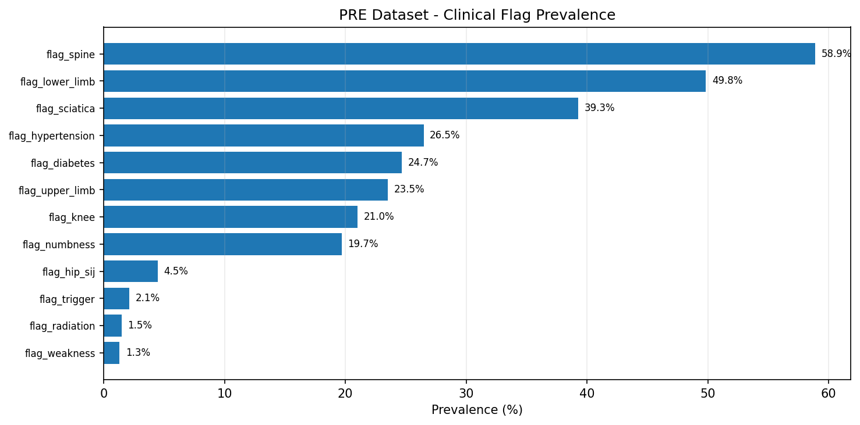
Figure 5. Prevalence of clinical features in the pre-
diagnosis dataset.

3. Unsupervised Post-Visit Dataset
The post-visit dataset was designed to discover patterns after the visit. It consists of 3551 records and 68 columns. This version adds diagnosis, procedure, plan, medication, follow-up notes, and a unified post_visit_text_norm field. Therefore, it is richer than the pre-diagnosis version and more capable of producing detailed clusters.
Table 7. Characteristics of the unsupervised post-visit dataset

Column | Completeness
complaint_clean | 94.93%
medical_history | 92.23%
surgical_history | 76.71%
drug_history | 59.98%
diagnosis_norm | 87.55%
procedure_norm | 82.60%
plan_norm | 81.47%
medication_norm | 90.14%
post_visit_text_norm | 99.94%
age | 98.45%
city | 99.35%
gender | 39.90%
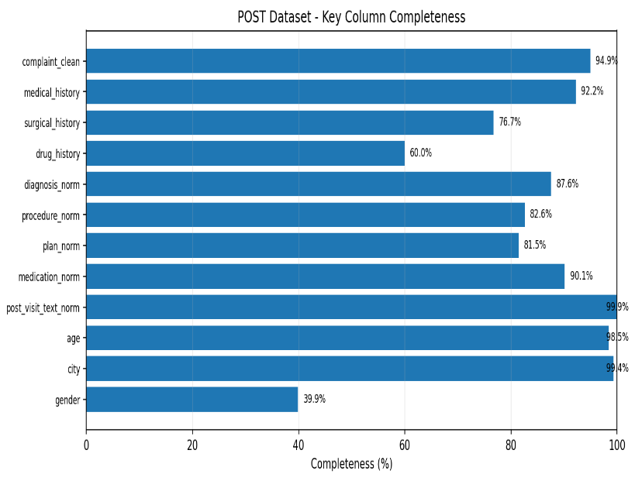
Figure 6. Completeness of key columns in the post-visit dataset.

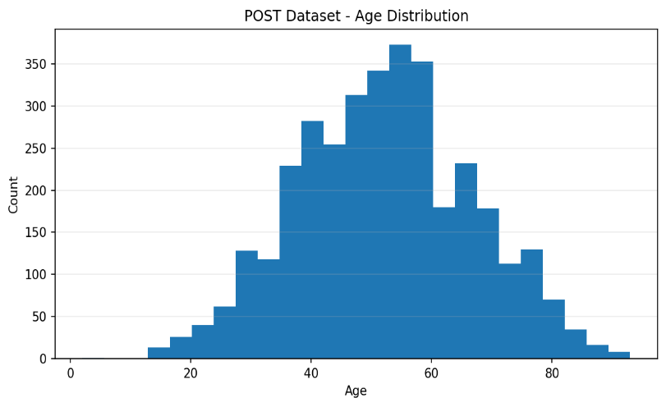
Figure 7. Age distribution in the post-visit dataset.

Table 8. Clinical indicators and post-visit features in the post-visit dataset

Feature | Prevalence
has_diagnosis | 85.53%
has_procedure | 79.81%
has_plan | 78.60%
has_medication | 88.96%
diagnosis_flag_spine | 26.30%
diagnosis_flag_hip_sij | 28.39%
diagnosis_flag_sciatica | 15.26%
diagnosis_flag_knee | 15.01%
diagnosis_is_mixed | 21.74%
flag_lower_limb | 49.62%
flag_upper_limb | 23.40%

VII. EXPERIMENTAL RESULTS AND DISCUSSION

1. Results of the Unsupervised Pre-Diagnosis Dataset
After text cleaning, TF-IDF, SVD, and KMeans were applied to the pre-diagnosis dataset. The results showed that a three-cluster solution provided a clinically meaningful interpretation: knee and osteoarthritis, spine/low back pain/sciatica, and hip/SIJ/pelvis. Although the geometric separation was not sharp, the clusters were clinically interpretable and suitable for early exploratory analysis.

Table 9. Pre-diagnosis clusters and clinical interpretation

Cluster | Clinical Interpretation | Count | Percentage
Cluster 0 | Knee / Osteoarthritis | 926 | 26.20%
Cluster 1 | Spine / Low Back Pain / Sciatica | 2023 | 57.23%
Cluster 2 | Hip / SIJ / Pelvis | 586 | 16.58%
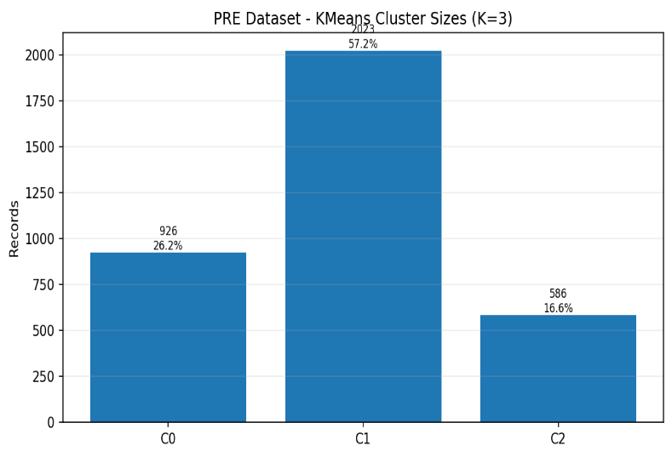

Figure 8. Sizes of pre-diagnosis clusters.
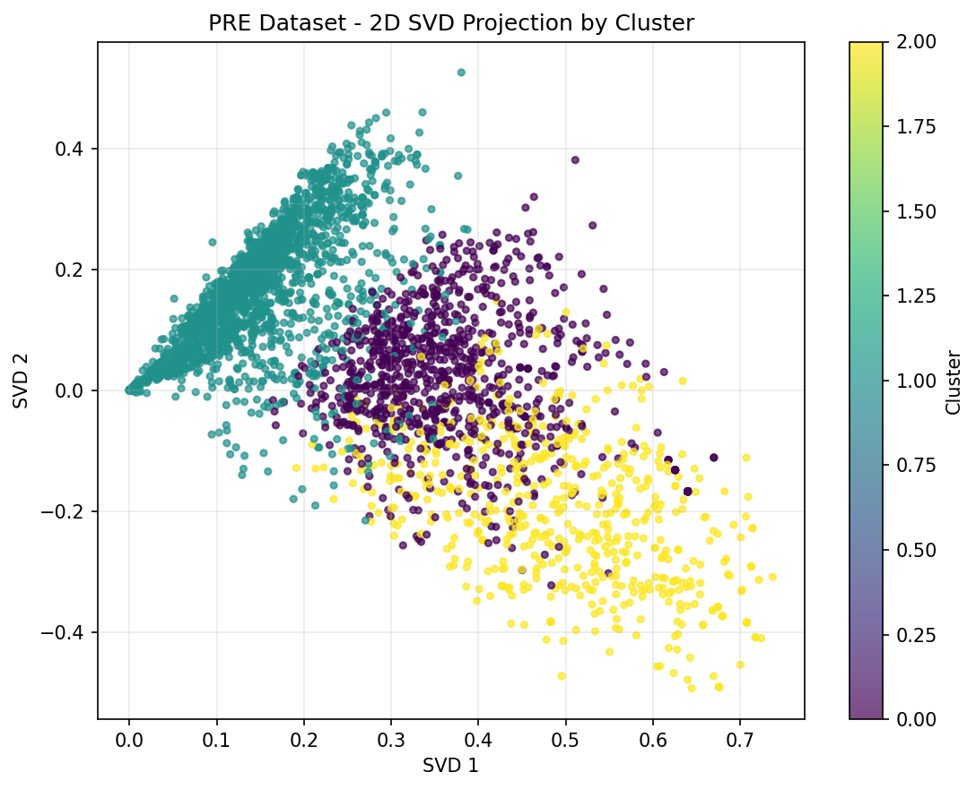
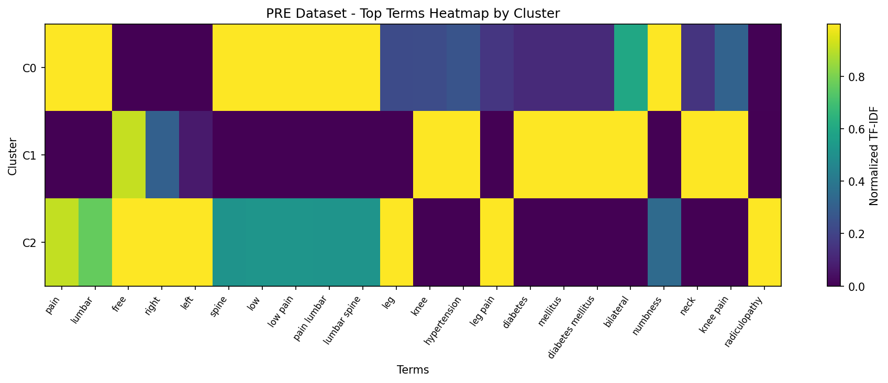
Figure 9. Two-dimensional SVD projection of pre-diagnosis clusters.
Figure 10. Heatmap of the most important medical terms within pre-diagnosis clusters.

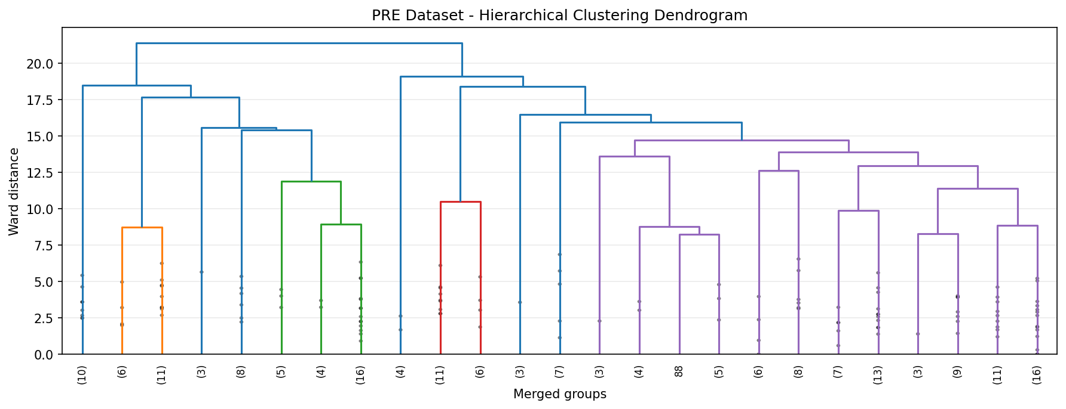
Figure 11. Hierarchical dendrogram of pre-diagnosis clusters.

2. Results of the Unsupervised Post-Visit Dataset
The post-visit dataset produced five clusters that were more detailed than the pre-diagnosis clusters because diagnosis, plan, procedure, and medication information were available. The figures showed that the post-visit dataset was able to separate patterns such as knee, hip/pelvis, upper limb, and spine disorders with higher interpretive value.

Table 10. Post-visit clusters and clinical interpretation

Cluster | Clinical Interpretation | Count | Percentage
Cluster 0 | Spine / Low Back / Lumbar | 231 | 6.51%
Cluster 1 | Spine / Low Back / Back | 612 | 17.23%
Cluster 2 | Pelvis / SIJ / Hip + Spine | 818 | 23.04%
Cluster 3 | Upper limb / Trigger / Myofascial pain | 628 | 17.69%
Cluster 4 | Knee / Osteoarthritis | 1262 | 35.54%

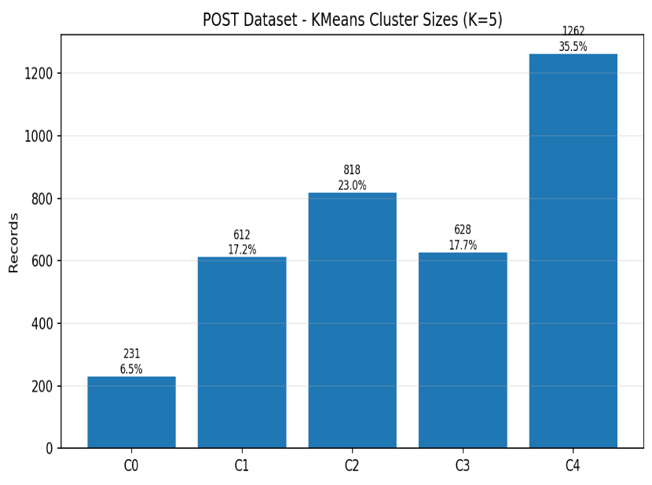
Figure 12. Sizes of post-visit clusters.

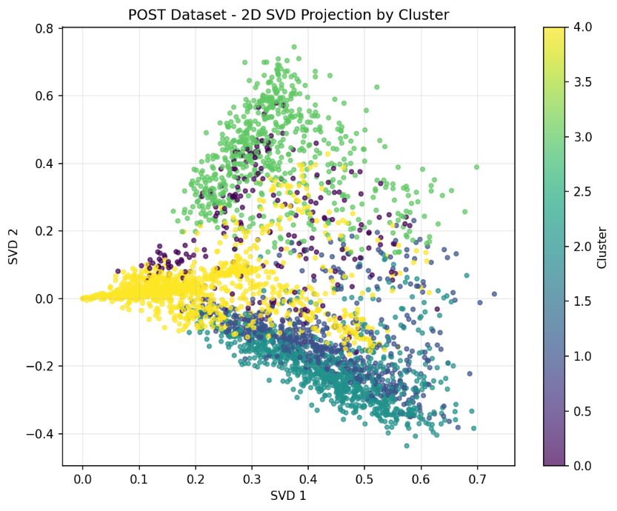
Figure 13. Two-dimensional SVD projection of post-visit clusters.

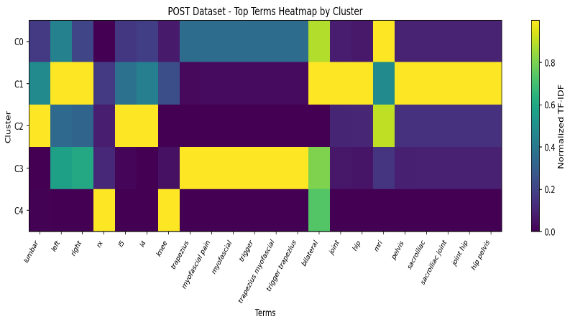
Figure 14. Heatmap of the most important medical terms within post-visit clusters.
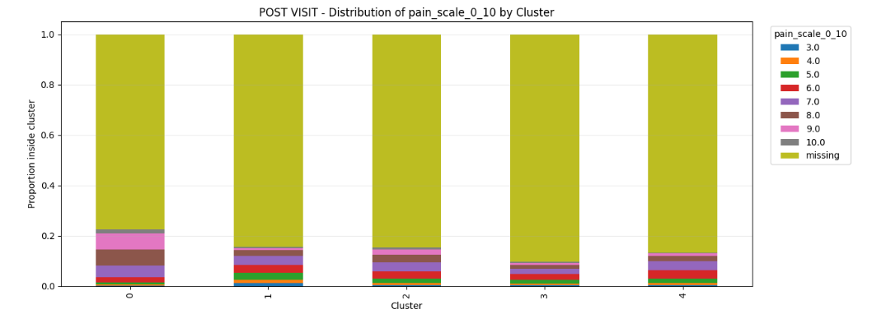
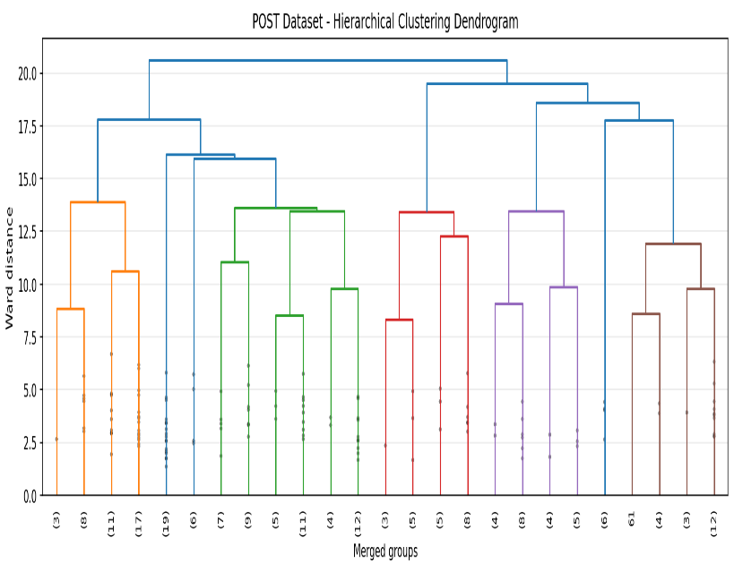
Figure 15. Hierarchical dendrogram of post-visit clusters

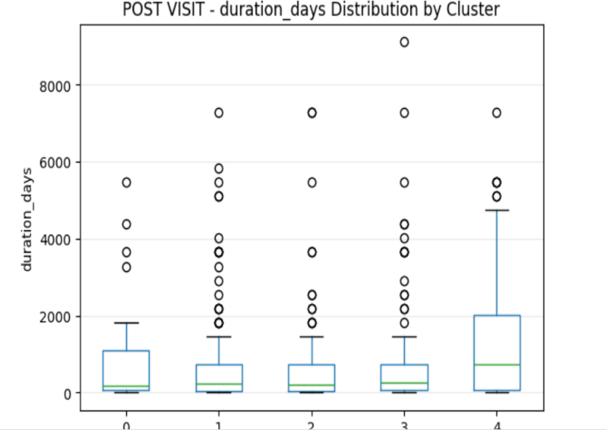
Figure16 Distribution of Pain Scale Scores Across Clusters in the Post-Visit Dataset
Figure 17 : Distribution of Symptom Duration in Days Across Clusters in the Post-Visit Dataset

3. Supervised Learning Results
In the supervised learning pathway, the SIJ/Hip Disorders class was removed in the final experiment because of its smaller size and overlap with other classes. This left 2250 records distributed across three classes. The results showed that LinearSVC was the best model, which is expected for short medical texts represented using TF-IDF.
Table 11. Comparison of supervised learning results

Rank | Model | Accuracy | Macro-F1
1 | LinearSVC C=0.03 | 71.96% | 71.87%
2 | LinearSVC C=0.10 | 70.80% | 70.64%
3 | RandomForest SVD | 70.53% | 70.42%
4 | Logistic Regression | 70.44% | 70.35%
5 | ExtraTrees SVD | 70.53% | 70.22%
6 | XGBoost SVD | 70.13% | 70.05%
7 | ANN / MLP SVD | 66.89% | 66.60%
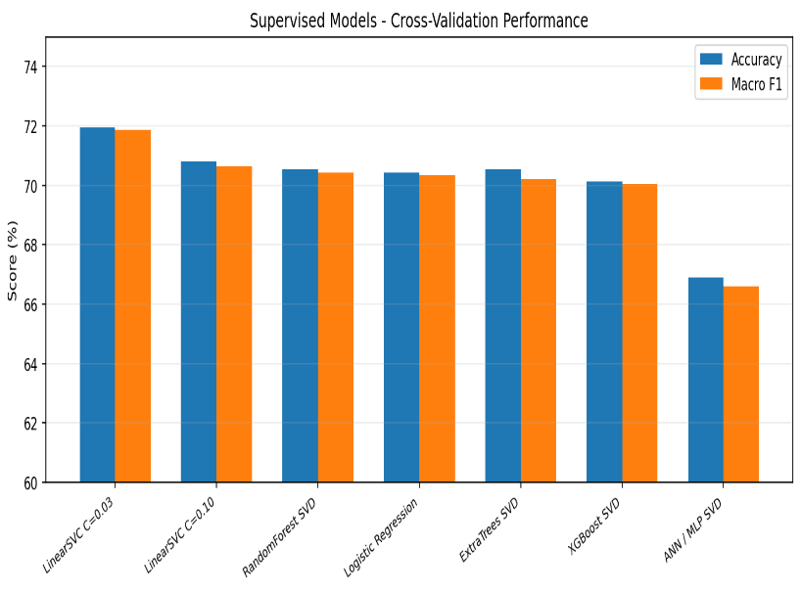
Figure 18. Comparison of supervised learning model performance.

Table 12. High-confidence classification analysis

Threshold | Coverage | Cases | Accuracy | Macro-F1
0.5 | 82.67% | 372 | 76.08% | 75.83%
0.6 | 66.44% | 299 | 78.60% | 78.54%
0.7 | 49.11% | 221 | 84.16% | 83.99%
0.8 | 30.22% | 136 | 86.76% | 85.79%
0.9 | 8.67% | 39 | 97.44% | 66.04%
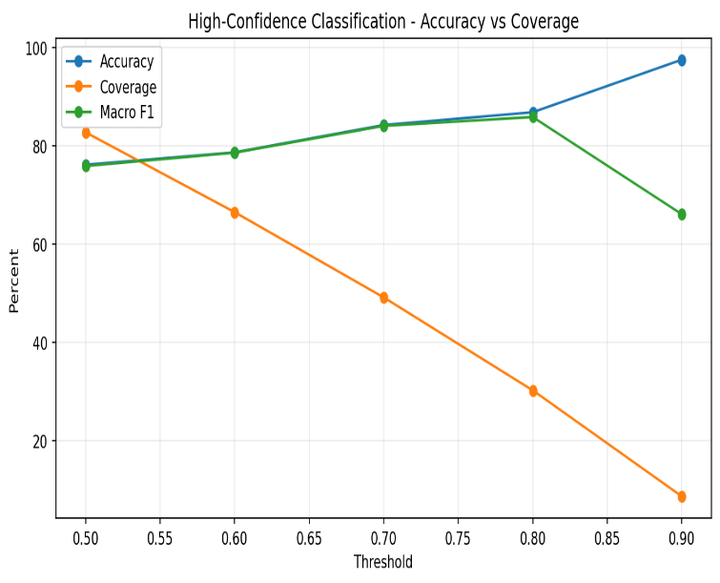
Figure 19. Accuracy-coverage curve in high-confidence classification.

The confidence analysis shows that the model should not be forced to classify all cases. At Threshold = 0.70, accuracy reached 84.16% with coverage of 49.11% of cases. This supports the construction of a clinical decision-support system that classifies clear cases and leaves ambiguous cases for human review.
The answers to the research questions show that the study findings generally support the validity of the proposed framework in combining unsupervised structural analysis and supervised classification for outpatient clinic records. Pre-diagnosis data demonstrated an ability to reveal initial clinical patterns, although these patterns were broad and overlapping. Unsupervised clustering favored three main clusters representing knee disorders, spine and low back pain disorders, and hip/SIJ disorders. This suggests that information available before diagnosis, such as complaint and medical history, is sufficient to reveal the general structure of the data, but it does not provide sharp clinical separation between similar cases.
In contrast, post-visit results showed that post-visit data were more detailed and more interpretable than pre-diagnosis data. The availability of additional information such as diagnosis, treatment plan, procedures, and medications led to five more specialized clusters. This indicates that post-visit data add not only a larger volume of information but also interpretive value that helps distinguish clinical patterns more accurately, such as knee clusters, hip and pelvis clusters, upper-limb clusters, and spine-disorder clusters.
In the supervised learning pathway, the results showed that the models were able to classify cases with moderate performance. The best model achieved an accuracy of 71.96% and a Macro-F1 score of 71.87%. Although this result is not very high, it is acceptable given the nature of real-world clinical data, which contain short texts, abbreviations, and missing values. The results also indicate that the performance limitation is not primarily due to weak algorithms, but to the nature of the data and labels themselves, especially the clinical and linguistic overlap between Spine Disorders and Sciatica/Radiculopathy. These two categories share similar terms and symptoms, such as low back pain, pain radiating to the leg, and nerve-root symptoms.
The high-confidence classification experiment also showed important practical value. Accuracy increased to 84.16% when only 49.11% of cases were classified. This indicates that the model becomes more effective when used as a clinical decision-support tool that classifies clear high-confidence cases and leaves ambiguous or overlapping cases for human review. Therefore, the model should not be viewed as a mandatory classifier for all cases, but as an assisting tool that can improve efficiency when applied within appropriate confidence limits.
The analytical figures also proved important for interpreting the results. SVD projections helped reveal the degree of overlap between clusters, the dendrogram clarified the hierarchical structure of relationships between cases, and heatmaps identified the most distinctive medical terms within each cluster. Thus, the figures were not merely visual presentation elements; they played an interpretive role in understanding the nature of the data, identifying the causes of overlap, and linking numerical results with clinical meaning.
Overall, the discussion shows that unsupervised learning provides important structural understanding of the data and helps discover latent clinical patterns, whereas supervised learning provides practical predictive capability that can be used for classification and decision support. However, both pathways were affected by the same issue: clinical and linguistic overlap between categories. Therefore, improving data quality, reviewing clinical labels, and standardizing complaint wording may have a greater effect on performance than simply increasing algorithmic complexity or using deeper models.
VIII. LIMITATIONS
Despite the strength of the design, several limitations exist:
- The data were obtained from outpatient clinics within a local Libyan context.
- Some important fields, such as pain score and symptom duration, had high missingness.
- Clinical texts were short and not fully standardized.
- There are clinically overlapping categories such as Spine Disorders and Sciatica/Radiculopathy.
- The study did not use radiographic images, MRI reports, or long-term follow-up data.
- Removing the SIJ/Hip Disorders class in the supervised pathway improved stability but reduced classification coverage.
- Deep learning models did not outperform other models, most likely because of dataset size and label overlap.

IX. CONCLUSION AND FUTURE WORK
This study presented an integrated framework for employing supervised and unsupervised machine learning to analyze outpatient clinic records for musculoskeletal disorders in Libya. The PRE results showed that pre-diagnosis data can reveal three broad clinical groups, whereas the POST results showed that post-visit data can reveal five more detailed and stable groups. In supervised learning, LinearSVC achieved the best performance with an accuracy of 71.96% and a Macro-F1 score of 71.87%.
The results indicate that improving performance requires not only more complex models but also better data and labels. Error analysis showed that overlap between Spine Disorders and Sciatica/Radiculopathy is one of the main causes of limited performance. The confidence analysis also showed that the model becomes more useful when it classifies only clear cases and leaves ambiguous cases for clinical review.
Future work may develop this study by increasing the dataset size from more clinics and cities, reviewing labels by specialized clinicians, adding MRI and X-ray reports, using ClinicalBERT, BioBERT, or Arabic medical language models, building confidence-based decision-support systems, using active learning to review ambiguous cases, testing semi-supervised learning, validating the model on external datasets, and building a clinical dashboard to display clusters, geographical distribution, and clinical patterns.
REFERENCES
Alzoubi, H., Alzubi, R., Ramzan, N., West, D., Al-Hadhrami, T., & Alazab, M. (2019). A review of automatic phenotyping approaches using electronic health records. Electronics, 8(11), 1235.
Alsentzer, E., Murphy, J., Boag, W., Weng, W.-H., Jin, D., Naumann, T., & McDermott, M. B. A. (2019). Publicly available clinical BERT embeddings. In Proceedings of the 2nd Clinical Natural Language Processing Workshop (pp. 72-78).
Bacco, L., Russo, F., Ambrosio, L., D’Antoni, F., Vollero, L., Vadalà, G., Dell’Orletta, F., Merone, M., Papalia, R., & Denaro, V. (2022). Natural language processing in low back pain and spine diseases: A systematic review. Frontiers in Surgery, 9, 957085.
Bazoge, A., Morin, E., Daille, B., & Gourraud, P.-A. (2023). Applying natural language processing to textual data from clinical data warehouses: Systematic review. JMIR Medical Informatics, 11, e42477.
Begum, T., Veeranki, B., Chike, O. J., Simard, J. F., Chen, J., Chaichian, Y., Mackey, S., Darnall, B. D., & Falasinnu, T. (2025). Refining chronic pain phenotypes: A comparative analysis of sociodemographic and disease-related determinants using electronic health records. The Journal of Pain.
Choi, E., Bahadori, M. T., Schuetz, A., Stewart, W. F., & Sun, J. (2016). Doctor AI: Predicting clinical events via recurrent neural networks. In Proceedings of the 1st Machine Learning for Healthcare Conference (Vol. 56, pp. 301-318). PMLR.
Dave, A. D., Ruaño, G., Kost, J., & Wang, X. (2022). Automated extraction of pain symptoms: A natural language approach using electronic health records. Pain Physician, 25, E245-E254.
De Freitas, J. K., Johnson, K. W., Golden, E., Nadkarni, G. N., Dudley, J. T., Böttinger, E. P., Glicksberg, B. S., & Miotto, R. (2021). Phe2vec: Automated disease phenotyping based on unsupervised embeddings from electronic health records. Patterns, 2(9), 100337.
GBD 2021 Low Back Pain Collaborators. (2023). Global, regional, and national burden of low back pain, 1990-2020, its attributable risk factors, and projections to 2050. The Lancet Rheumatology, 5(6), e316-e329.
Jenssen, M. D. K., Bakkevoll, P. A., Ngo, P. D., Budrionis, A., Fagerlund, A. J., Tayefi, M., Bellika, J. G., & Godtliebsen, F. (2021). Machine learning in chronic pain research: A scoping review. Applied Sciences, 11(7), 3205.
Landi, I., Glicksberg, B. S., Lee, H.-C., Cherng, S., Landi, G., Danieletto, M., Dudley, J. T., Furlanello, C., & Miotto, R. (2020). Deep representation learning of electronic health records to unlock patient stratification at scale. npj Digital Medicine, 3, 96.
Li, Y., Rao, S., Ayala Solares, J. R., Hassaine, A., Canoy, D., Zhu, Y., Rahimi, K., & Salimi-Khorshidi, G. (2020). BEHRT: Transformer for electronic health records. Scientific Reports, 10.
Lyu, W., Dong, X., Wong, R., Zheng, S., Abell-Hart, K., Wang, F., & Chen, C. (2022). A multimodal transformer: Fusing clinical notes with structured EHR data for interpretable in-hospital mortality prediction. AMIA Annual Symposium Proceedings, 719-728.
Mohammed, T. J., Chew, X., Alnoor, A., Khaw, K. W., Albahri, A. S., Teoh, W. L., Chong, Z. L., & Saha, S. (2024). A systematic review of artificial intelligence in orthopaedic disease detection: A taxonomy for analysis and trustworthiness evaluation. International Journal of Computational Intelligence Systems, 17, 303.
Nelson, A. E., & Arbeeva, L. (2022). Narrative review of machine learning in rheumatic and musculoskeletal diseases for clinicians and researchers: Biases, goals, and future directions. The Journal of Rheumatology, 49(11), 1191-1200.
Rasmy, L., Xiang, Y., Xie, Z., Tao, C., & Zhi, D. (2021). Med-BERT: Pretrained contextualized embeddings on large-scale structured electronic health records for disease prediction. npj Digital Medicine, 4.
Si, Y., Du, J., Li, Z., Jiang, X., Miller, T., Wang, F., Zheng, W. J., & Roberts, K. (2021). Deep representation learning of patient data from electronic health records: A systematic review. Journal of Biomedical Informatics, 115, 103671.
Tang, A. S., Woldemariam, S. R., Miramontes, S., Norgeot, B., Oskotsky, T. T., & Sirota, M. (2024). Harnessing EHR data for health research. Nature Medicine, 30, 1847-1855.
Vaid, A., Landi, I., Nadkarni, G., & Nabeel, I. (2023). Using fine-tuned large language models to parse clinical notes in musculoskeletal pain disorders. The Lancet Digital Health, 5(12), e855-e858.
World Health Organization. (2022). Musculoskeletal health.
Wu, H., Chen, Z., Gu, J., Jiang, Y., Gao, S., Chen, W., & Miao, C. (2024). Predicting chronic pain and treatment outcomes using machine learning models based on high-dimensional clinical data from a large retrospective cohort. Clinical Therapeutics.
Yang, S., Varghese, P., Stephenson, E., Tu, K., & Gronsbell, J. (2023). Machine learning approaches for electronic health records phenotyping: A methodological review. Journal of the American Medical Informatics Association, 30(2), 367-381.

