Design and Implementation of MPLS Layer 2 VPN (Martini VLL) with Traffic Engineering and Fast Reroute Using Huawei eNSP

Ahmed El Saiti 1 , Mohammed Tarek 2 , Rajab ELwerfli 3 , Osama Bakar4 ,

1 2 3 4 Faculty of Computer Technology and Information, Al-Salam International University, , Benghazi, Libya

______________________________________________________________________________________________________

Abstract:

This study presents the design, implementation, and evaluation of a Multiprotocol Label Switching Layer 2 Virtual Private Network (MPLS L2VPN) based on the Martini Virtual Leased Line (VLL) model within a Huawei eNSP simulation environment. The proposed architecture is designed to provide scalable and reliable Layer 2 connectivity between geographically distributed customer sites over an MPLS-enabled service provider backbone.The network design integrates Open Shortest Path First (OSPF) as the Interior Gateway Protocol (IGP), while Multiprotocol Label Switching (MPLS) and Label Distribution Protocol (LDP) are used to establish Label Switched Paths (LSPs) and pseudowire connections. In addition, MPLS Traffic Engineering (MPLS-TE) and Fast Reroute (FRR) mechanisms are implemented to optimize traffic forwarding and enhance network resilience in the event of failures.The proposed solution was validated through connectivity tests, tunnel status verification, and failure recovery scenarios. The results confirm the successful establishment of Martini-based pseudowires, stable end-to-end Layer 2 connectivity between customer sites, and correct operation of MPLS-TE tunnels. Furthermore, the FRR mechanism demonstrated rapid recovery from a simulated link failure, with only a single packet lost during traffic switchover, ensuring service continuity under failure conditions.Overall, the results demonstrate that the integration of MPLS L2VPN, MPLS Traffic Engineering, and Fast Reroute provides a robust, scalable, and resilient solution for delivering high-performance Layer 2 services in service provider and enterprise networks.

الملخص
تقدم هذه الدراسة تصميم وتنفيذ وتقييم شبكة افتراضية خاصة من الطبقة الثانية بتقنية تبديل الملصقات متعددة البروتوكولات (MPLS L2VPN) استنادًا إلى نموذج خط مارتيني الافتراضي المؤجر (VLL) ضمن بيئة محاكاة Huawei eNSP. صُممت البنية المقترحة لتوفير اتصال موثوق وقابل للتوسع من الطبقة الثانية بين مواقع العملاء الموزعة جغرافيًا عبر بنية أساسية لمزود الخدمة تدعم تقنية MPLS. يدمج تصميم الشبكة بروتوكول OSPF كبروتوكول بوابة داخلية (IGP)، بينما يُستخدم كل من تبديل الملصقات متعدد البروتوكولات (MPLS) وبروتوكول توزيع الملصقات (LDP) لإنشاء مسارات تبديل الملصقات (LSPs) ووصلات الأسلاك الافتراضية. بالإضافة إلى ذلك، تم تطبيق آليتي هندسة حركة مرور MPLS (MPLS-TE) وإعادة التوجيه السريع (FRR) لتحسين توجيه حركة المرور وتعزيز مرونة الشبكة في حالة الأعطال. تم التحقق من صحة الحل المقترح من خلال اختبارات الاتصال، والتحقق من حالة النفق، وسيناريوهات استعادة الأعطال. تؤكد النتائج نجاح إنشاء وصلات افتراضية قائمة على بروتوكول مارتيني، واتصال مستقر من طرف إلى طرف بين مواقع العملاء على مستوى الطبقة الثانية، والتشغيل السليم لأنفاق MPLS-TE. علاوة على ذلك، أظهرت آلية إعادة التوجيه السريع (FRR) تعافيًا سريعًا من عطل مُحاكٍ في الوصلة، حيث لم تُفقد سوى حزمة بيانات واحدة أثناء تحويل حركة البيانات، مما يضمن استمرارية الخدمة في ظروف الأعطال. وبشكل عام، تُظهر النتائج أن دمج MPLS L2VPN وهندسة حركة بيانات MPLS وإعادة التوجيه السريع يوفر حلاً قويًا وقابلاً للتوسع ومرنًا لتقديم خدمات الطبقة الثانية عالية الأداء في شبكات مزودي الخدمة وشبكات المؤسسات.

INTRODUCTION
As the global economy continues to expand, enterprises increasingly operate across geographically distributed locations to deliver services to a wider customer base. This expansion has created a strong demand for secure, efficient, and scalable network connectivity solutions that enable seamless communication between branch offices and allow employees to access corporate resources from any location.
Initially, service providers addressed this demand by offering leased line solutions. However, leased lines present significant limitations in terms of scalability, cost, and manageability, making them impractical when the number of branch offices increases rapidly or when large-scale deployment is required [1]. Subsequently, technologies such as Asynchronous Transfer Mode (ATM) and Frame Relay (FR) were introduced to provide virtual circuit-based connectivity. Although these solutions enabled the creation of private enterprise networks over shared infrastructure, they were primarily based on point-to-point Layer 2 connections, which made network configuration and maintenance complex, particularly when new sites were added [2].With the widespread adoption of IP networks, service providers began leveraging existing

infrastructure to deliver more cost-effective and scalable private networking solutions. Multiprotocol Label Switching (MPLS) emerged as a key technology in this context, combining the flexibility of IP routing with the efficiency of connection-oriented forwarding. By using short, fixed-length

labels to forward traffic through the network, MPLS significantly improves forwarding performance and enables advanced services such as traffic engineering, Quality of Service (QoS), and Virtual Private Networks (VPNs). As a result, MPLS has become a fundamental technology in modern service provider networks due to its scalability, flexibility, and support for policy-based routing [2].

MPLS VPN services are broadly classified into Layer 3 VPN (L3VPN) and Layer 2 VPN (L2VPN). L2VPN encompasses two primary deployment models: Virtual Private LAN Service (VPLS), which supports multipoint-to-multipoint connectivity, and Virtual Leased Line (VLL), which provides point-to-point connectivity between customer sites. From the customer perspective, the MPLS backbone operates as a transparent Layer 2 switching network, enabling seamless interconnection between geographically separated locations.

This study focuses on the design and implementation of an MPLS L2VPN solution in VLL mode using the Martini pseudowire protocol, deployed within a Huawei eNSP simulation environment. The proposed architecture interconnects two enterprise networks—Almadar and Libyana—across a shared MPLS provider backbone through PE1 and PE2 routers. The objective is to evaluate the effectiveness of Martini-based Layer 2 connectivity, enhanced by MPLS Traffic Engineering and Fast Reroute mechanisms, in providing a resilient and high-performance transport solution [3].

BACKGROUND OF THE STUDY
This section provides an overview of the key networking technologies that form the foundation of the proposed MPLS L2VPN architecture. Understanding these technologies is essential for evaluating the design decisions and implementation choices made in this study. The technologies discussed in this work include Open Shortest Path First (OSPF), Multiprotocol Label Switching (MPLS), Traffic Engineering, and the primary L2VPN deployment models.

2.1 Open Shortest Path First (OSPF)
Open Shortest Path First (OSPF) is a link-state Interior Gateway Protocol (IGP) widely used in IP networks to determine efficient routing paths for data forwarding. It operates within a single Autonomous System (AS) and is designed to provide fast convergence, scalability, and reliable routing in large and complex network environments.

OSPF is particularly well suited for service provider networks due to its support for Traffic Engineering extensions. These extensions allow the protocol to populate the Traffic Engineering Database (TED) with detailed link-state information, which is used for the computation of optimal MPLS Traffic Engineering (MPLS-TE) paths [7].

2.2 Multiprotocol Label Switching (MPLS)
Multiprotocol Label Switching (MPLS) is a high-performance packet forwarding technology widely deployed in modern service provider and enterprise networks to enhance the speed, efficiency, and scalability of data transmission. Unlike traditional IP routing, which relies on longest-prefix matching at each hop to make forwarding decisions, MPLS forwards traffic based on short, fixed-length labels, enabling faster and more efficient packet switching across the network.
In this study, MPLS forms the core transport infrastructure over which the Layer 2 VPN (L2VPN) service is implemented. It supports a wide range of advanced networking capabilities, including Virtual Private Networks (VPNs), Traffic Engineering (TE), and Quality of Service (QoS). These features make MPLS particularly suitable for service provider environments that require scalable, reliable, and performance-oriented data transport solutions [9].
2.3 Traffic Engineering (TE)
Traffic Engineering (TE) is an advanced networking technique used to optimize network performance and resource utilization by explicitly controlling the flow of data traffic. In traditional IP networks, traffic is typically forwarded along the shortest path calculated by routing protocols such as OSPF. While this approach is efficient in simple scenarios, it can lead to congestion on certain links while others remain underutilized.

Traffic Engineering addresses this limitation by enabling the use of predefined explicit paths that take into account network resources, available bandwidth, and administrative policies. This allows for more balanced traffic distribution and improved overall network performance.

In this study, MPLS Traffic Engineering (MPLS-TE) is implemented using RSVP-TE as the signaling protocol to establish explicit Label Switched Paths (LSPs) between Provider Edge (PE) routers. This approach enables optimized traffic forwarding across the provider backbone and forms the basis for Fast Reroute (FRR) protection, which ensures rapid service recovery in the event of a link failure [11].

2.4 Layer 2 Virtual Private Network (L2VPN)
Layer 2 Virtual Private Network (L2VPN) is a technology that provides VPN services at the data link layer of the OSI model. It enables geographically separated local area networks (LANs) to communicate over a shared wide area network (WAN) infrastructure as if they were part of a single unified network. L2VPN is widely deployed in enterprise and service provider environments to interconnect branch offices, data centers, and cloud infrastructures while ensuring traffic isolation and efficient data forwarding.

L2VPN technologies rely on underlying transport mechanisms such as Multiprotocol Label Switching (MPLS) to deliver scalable, flexible, and high-performance connectivity solutions. From the customer perspective, the provider’s WAN infrastructure is transparent, allowing Customer Edge (CE) devices to exchange Layer 2 frames without awareness of the intermediate service provider network.

MPLS-based L2VPN implementations are generally classified into different deployment models. Among these, Virtual Leased Line (VLL) using the Martini pseudowire protocol is the primary focus of this study [1].

2.4.1 Circuit Cross Connect (CCC) Mode
Circuit Cross Connect (CCC) is an L2VPN implementation mode in which Virtual Leased Line (VLL) connectivity is established using static Label Switched Paths (LSPs). In this mode, a single label layer — the tunnel label — is used for forwarding user traffic, with each LSP being exclusively dedicated to a single virtual circuit. This dedicated allocation enables predictable forwarding behavior and provides inherent Quality of Service (QoS) advantages due to the absence of resource sharing between virtual circuits [2].

CCC supports two operational modes. In local CCC mode, two Customer Edge (CE) devices are connected to the same Provider Edge (PE) router, where the PE acts as a Layer 2 switch to forward traffic between them. In remote CCC mode, CE devices are connected to different PE routers, which are interconnected through dedicated static LSPs acting as transport tunnels. In both cases, transparent Layer 2 connectivity is provided without the need for signaling protocols to exchange virtual circuit information.

The MPLS L2VPN architecture in CCC mode is illustrated in Figure 1. The figure demonstrates both local and remote CCC scenarios, highlighting how bidirectional static LSPs are used to establish end-to-end virtual circuits across the provider backbone.
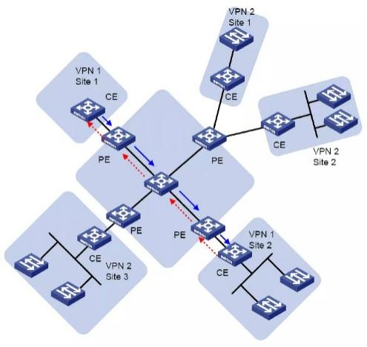

Figure 1: MPLS L2VPN Architecture in CCC Mode

2.4.2 Martini Mode
Martini mode is an L2VPN implementation that uses the Label Distribution Protocol (LDP) as its signaling mechanism to establish and maintain virtual circuit (VC) connections between Provider Edge (PE) routers. In this mode, a targeted LDP session is established between PE routers, through which each PE allocates and advertises VC labels for individual virtual circuits. These labels are then used to establish pseudowire connections, enabling bidirectional Layer 2 communication between customer sites.

Unlike CCC mode, Martini mode does not support local switching. However, it provides significantly improved scalability by allowing multiple virtual circuits to share a single Label Switched Path (LSP) across the service provider backbone. At the ingress PE, each packet is encapsulated with a two-layer label stack: an inner VC label that identifies the specific virtual circuit, and an outer tunnel label that determines the path across the MPLS network.

The MPLS L2VPN architecture in Martini mode is illustrated in Figure 2, showing how multiple virtual circuits share a common LSP across the provider network and demonstrating the label stacking and forwarding process between PE routers.

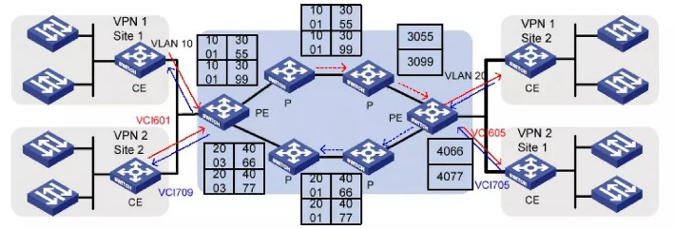

Figure 2: MPLS L2VPN Architecture in Martini Mode

3. RELATED WORK
MPLS Layer 2 Virtual Private Network (L2VPN) has evolved into a mature networking technology supported by several standardized frameworks and extensive prior research. However, most existing studies primarily focus on architectural design, security mechanisms, QoS provisioning, or isolated implementations of specific L2VPN models. In contrast, limited research has addressed integrated implementations that combine L2VPN with Traffic Engineering and Fast Reroute mechanisms within a unified simulation and evaluation environment. This section reviews the most relevant prior work in L2VPN architecture, security, QoS, and implementation frameworks.

Rosen (2005) presented a comprehensive framework for L2VPN networks, including Virtual Private LAN Service (VPLS) and Virtual Private Wire Service (VPWS). The study discussed key architectural models and signaling mechanisms, such as BGP-based control and MPLS forwarding, and highlighted the importance of scalability, QoS, and traffic engineering in large service provider networks.

Kim et al. (2006) investigated the design and implementation of a Martini-based L2VPN, focusing on pseudowire configuration between Provider Edge (PE) and Customer Edge (CE) routers. Their work demonstrated the feasibility of Martini deployments in service provider environments, including configuration validation and end-to-end connectivity verification.

Li et al. (2012) analyzed security threats in L2VPN environments, such as MAC address spoofing, ARP poisoning, and Denial of Service (DoS) attacks. The authors proposed mitigation techniques including MAC filtering, ARP inspection, and traffic control mechanisms to improve overall network security.

Fu et al. (2011) proposed a secure key management protocol for L2VPN networks, addressing challenges in key distribution and lifecycle management. The approach aimed to ensure confidentiality, integrity, and secure communication between network endpoints.

Raza et al. (2014) introduced a QoS provisioning framework for L2VPN networks based on traffic classification and resource allocation policies, improving service quality and performance consistency across different traffic types.

Wang and Li (2014) presented a Kompella-based L2VPN implementation model, focusing on control plane and data plane design, as well as scalable provisioning using BGP-based signaling mechanisms.
IETF RFC 4447 (2006) defines the architecture and procedures for establishing pseudowires in MPLS networks using LDP signaling, enabling transparent transport of Layer 2 services such as Ethernet, Frame Relay, and ATM over MPLS tunnels. RFC 4761 (2007) complements this by defining BGP-based auto-discovery and signaling mechanisms for scalable L2VPN deployments in large provider networks.

Table1: Summary of Related Work

Author | Technology | Objective | Result
Rosen (2005) | L2VPN Framework | Define L2VPN architecture | Standardized Architecture
Kim et al. (2006) | Martini L2VPN | Design and Implementation | Successful Deployment
Wang & Li (2014) | Kompella L2VPN | Software Implementation | Scalable Solution
Raza et al. (2014) | QoS for L2VPN | QoS Provisioning | Improved Service quality
Li et al. (2012) | L2VPN Security | Security enhancement | Improved network security

Overall, existing literature has extensively addressed individual aspects of MPLS Layer 2 VPN technologies, including architecture, security, QoS, and signaling mechanisms. However, most studies do not consider an integrated evaluation that combines MPLS L2VPN with MPLS Traffic Engineering and Fast Reroute mechanisms within a unified simulation and testing environment.

In contrast, this study presents an integrated implementation of a Martini-based MPLS L2VPN combined with MPLS-TE and FRR within a Huawei eNSP simulation environment. The proposed design not only establishes Layer 2 connectivity between geographically distributed customer sites, but also evaluates tunnel behavior, service availability, and network resilience under link failure conditions. Therefore, this work contributes a practical implementation and validation framework demonstrating how MPLS L2VPN, MPLS-TE, and FRR can operate together to deliver reliable and resilient Layer 2 services.

4. METHODOLOGY
This study adopted an experimental methodology to design, implement, and evaluate a Martini-based MPLS Layer 2 Virtual Private Network (L2VPN) enhanced with MPLS Traffic Engineering (MPLS-TE) and Fast Reroute (FRR) mechanisms. The objective was to establish transparent Layer 2 connectivity between geographically distributed customer sites while ensuring service continuity during network failures.

The proposed network was implemented within the Huawei Enterprise Network Simulation Platform (eNSP), which provided a controlled and reproducible environment for configuring and testing MPLS-based services. The topology consisted of two Provider Edge (PE) routers and four Customer Edge (CE) routers interconnected through primary and backup links. Open Shortest Path First (OSPF) was deployed as the Interior Gateway Protocol (IGP) to provide dynamic routing and network reachability across the provider core. Multiprotocol Label Switching (MPLS) and Label Distribution Protocol (LDP) were subsequently configured to establish Label Switched Paths (LSPs) and support pseudowire connectivity between customer sites.

Martini Virtual Leased Line (VLL) technology was implemented to provide transparent point-to-point Layer 2 connectivity between remote customer locations, allowing Customer Edge (CE) devices to communicate as if connected through a dedicated leased line. MPLS Traffic Engineering (MPLS-TE) tunnels were established using RSVP-TE signaling to optimize traffic forwarding and establish explicit paths between Provider Edge routers. Fast Reroute (FRR) protection mechanisms were configured on the MPLS-TE tunnels to ensure rapid traffic switchover and maintain service continuity in the event of a primary link failure.

The implementation process followed a structured sequence that included network design, IP addressing allocation, routing protocol configuration, MPLS and LDP deployment, pseudowire establishment, MPLS-TE tunnel creation, and FRR protection activation. Network functionality and performance were verified through connectivity tests, tunnel status monitoring, pseudowire verification, and failure recovery experiments. Ping and Traceroute utilities were used alongside Huawei-specific verification commands to assess forwarding behavior and path selection, while Wireshark was employed to capture and analyze network traffic during normal operation and failure recovery scenarios. The collected results were analyzed to evaluate the effectiveness, reliability, and resiliency of the proposed MPLS L2VPN solution.

5. RESULTS AND DISCUSSION
5.1 Network Components and Simulation Environment

The proposed MPLS L2VPN network was implemented and evaluated within the Huawei Enterprise Network Simulation Platform (eNSP) Version 1.3.00.100 running on Oracle VirtualBox. The simulation environment was designed to emulate a realistic enterprise-service provider scenario, enabling comprehensive evaluation of MPLS L2VPN functionality, traffic engineering efficiency, and network resiliency under both normal and failure conditions.
The network topology consists of two Provider Edge (PE) routers responsible for MPLS and L2VPN service provisioning, and four Customer Edge (CE) routers representing geographically distributed customer sites. The CE routers are connected to the PE routers through Ethernet interfaces, while the PE routers are interconnected through two physical links — a primary link via GE0/0/0 and a backup link via GE0/0/3 — to support redundancy and FRR protection.
The deployed technologies include OSPF, MPLS, LDP, RSVP-TE, Martini-based VLL, MPLS-TE, and FRR, which collectively form the service delivery and protection infrastructure of the proposed solution.
Network traffic was captured and analyzed using Wireshark, while connectivity verification and performance evaluation were performed using Ping and Traceroute utilities alongside Huawei-specific verification commands. These tools enabled observation of packet forwarding behavior, tunnel establishment, failure recovery processes, and overall service performance.
5.2 Network Topology and Addressing Scheme

The proposed network topology consists of four Customer Edge (CE) routers connected through two Provider Edge (PE) routers across an MPLS backbone. OSPF is used as the IGP within the provider network, while MPLS, LDP, MPLS-TE, FRR, and Martini-based L2VPN are deployed to provide reliable Layer 2 connectivity between customer sites.

The two PE routers are centrally positioned within the provider core, each serving two CE routers representing distinct customer sites. They are interconnected via dual physical links to support path redundancy and FRR protection. The topology is illustrated in Figure 3.

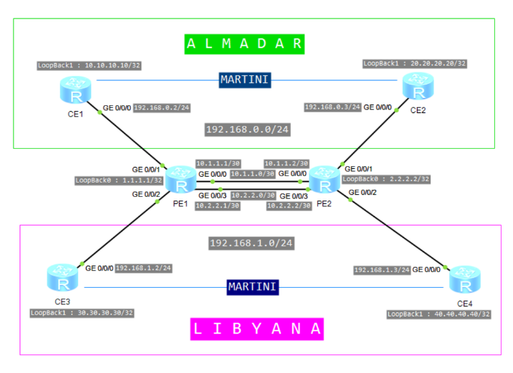
Figure 3. Proposed MPLS L2VPN Network Topology

The IP addressing scheme was designed to provide unique identification for all network devices and interfaces within the
Figure 3. LAB TOPOLOGY

simulation environment. Loopback interfaces were configured to serve as router identifiers and MPLS-TE tunnel endpoints, while point-to-point /30 subnets were assigned to inter-PE links. Customer Edge routers were assigned private IP address ranges to emulate geographically distributed enterprise sites interconnected through the MPLS L2VPN infrastructure.

Note: Tunnel0/0/0 interfaces on PE routers are configured as unnumbered interfaces using LoopBack0 addresses for MPLS-TE tunnel establishment

Table 2 IP Addressing Scheme

Device | Interface | IP Address | Prefix Length | Purpose
PE1 | LoopBack0 | 1.1.1.1 | /32 | Router ID / TE Tunnel Source
PE1 | GE0/0/0 | 10.1.1.1 | /30 | Link to PE2 (Primary)
PE1 | GE0/0/3 | 10.2.2.1 | /30 | Link to PE2 (Backup)
PE1 | Tunnel0/0/0 | Unnumbered (uses LoopBack0) | - | MPLS-TE Tunnel Interface
PE2 | LoopBack0 | 2.2.2.2 | /32 | Router ID / TE Tunnel Destination
PE2 | GE0/0/0 | 10.1.1.2 | /30 | Link to PE1 (Primary)
PE2 | GE0/0/3 | 10.2.2.2 | /30 | Link to PE1 (Backup)
PE2 | Tunnel0/0/0 | Unnumbered (uses LoopBack0) | - | MPLS-TE Tunnel Interface
CE1 | LoopBack1 | 10.10.10.10 | /32 | Customer Site 1
CE1 | GE0/0/0 | 192.168.0.2 | /24 | Access Link to PE1
CE2 | LoopBack1 | 20.20.20.20 | /32 | Customer Site 2
CE2 | GE0/0/0 | 192.168.0.3 | /24 | Access Link to PE2
CE3 | LoopBack1 | 30.30.30.30 | /32 | Customer Site 3
CE3 | GE0/0/0 | 192.168.1.2 | /24 | Access Link to PE1
CE4 | LoopBack1 | 40.40.40.40 | /32 | Customer Site 4
CE4 | GE0/0/0 | 192.168.1.3 | /24 | Access Link to PE2

Note: CE1 and CE2 share the 192.168.0.0/24 subnet, while CE3 and CE4 share the 192.168.1.0/24 subnet. This configuration was intentionally implemented to emulate Layer 2 adjacency between geographically separated customer sites through Martini-based MPLS L2VPN services.

5.3 Network Configuration
5.3.1 OSPF Configuration
Open Shortest Path First (OSPF) was deployed as the Interior Gateway Protocol within the MPLS core network to provide dynamic routing and reachability between the Provider Edge routers (PE1 and PE2). OSPF was selected due to its link-state nature, fast convergence capabilities, and native support for Traffic Engineering extensions, which are essential for establishing MPLS-TE tunnels in this topology.

Both PE1 and PE2 were configured under OSPF process ID 1, and all directly connected interfaces — including Loopback0, GE0/0/0, and GE0/0/3 — were advertised within OSPF Area 0 (the backbone area). Loopback interfaces were treated as /32 host routes to ensure stable router identification and reliable tunnel endpoint advertisement across the MPLS domain.

OSPF Traffic Engineering (OSPF-TE) extensions were additionally enabled on both PE routers to populate the Traffic Engineering Database (TED) with link-state information such as available bandwidth and interface metrics. This information is subsequently utilized by the Constraint-Based Shortest Path First (CSPF) algorithm to compute optimal explicit paths for MPLS-TE tunnels.

The OSPF neighbor adjacency between PE1 and PE2 was successfully established over both the primary link (GE0/0/0) and the backup link (GE0/0/3), ensuring routing redundancy within the provider core. Following convergence, each router maintained a synchronized Link-State Database (LSDB), enabling accurate path computation and supporting overall MPLS L2VPN stability.

5.3.2 MPLS, LDP, and MPLS-TE Configuration
Multiprotocol Label Switching (MPLS) was enabled globally and on all relevant interfaces of both PE routers to establish the label-switching infrastructure required for L2VPN service delivery. MPLS forms the core forwarding mechanism of the proposed network, replacing traditional IP-based routing with label-based packet forwarding to achieve faster and more efficient data transmission across the provider network.

Label Distribution Protocol (LDP) was configured to automate label distribution between PE1 and PE2, enabling the establishment of Label Switched Paths (LSPs) across the MPLS domain. LDP sessions were initiated using Loopback0 interfaces as transport addresses, ensuring session stability even in the event of a physical interface failure.

Upon successful LDP session establishment, each router populated its Label Information Base (LIB) with label mappings received from its peer, enabling bidirectional label-switched forwarding between PE1 and PE2. The combination of OSPF-based reachability and LDP-based label distribution ensured correct Forwarding Equivalence Class (FEC) mapping and efficient packet forwarding through the MPLS core.

MPLS Traffic Engineering (MPLS-TE) was then enabled to support constraint-based path computation and explicit tunnel creation. RSVP-TE was used as the signaling protocol for tunnel establishment, allowing bandwidth reservation along computed paths and ensuring deterministic forwarding behavior for L2VPN traffic.

5.3.3 Fast Reroute (FRR) Configuration
Fast Reroute (FRR) was enabled on the MPLS-TE tunnels to provide rapid protection in the event of a primary link failure. In this implementation, Link Protection Fast Reroute was employed to protect the primary link between PE1 and PE2. FRR operates at the MPLS layer, enabling immediate traffic switchover to a pre-established backup path without waiting for routing protocol reconvergence.

Upon detection of a failure on the primary link, traffic is automatically redirected to the backup path traversing GE0/0/3, ensuring uninterrupted L2VPN service delivery between customer sites. This approach provides fast local repair and enhances network resiliency by maintaining service continuity during link failure conditions.

5.3.4 Martini VLL Configuration
The Layer 2 VPN service was implemented using the Martini Virtual Leased Line (VLL) mode, which relies on LDP as its signaling mechanism for establishing pseudowire connections between PE routers. Martini VLL was selected due to its simplicity, efficiency, and suitability for point-to-point Layer 2 connectivity over an MPLS core network.
Two independent VLL connections were established to support two customer groups. The first pseudowire, identified by VC-ID 100, interconnects CE1 and CE2 (Almadar sites). The second pseudowire, identified by VC-ID 200, interconnects CE3 and CE4 (Libyana sites).

On each PE router, access-side interfaces connected to CE devices were bound to their respective VLL instances. A remote LDP session was established between PE1 and PE2 using Loopback0 addresses as transport endpoints, over which VC label information was exchanged.

After session establishment, each PE router allocated a VC label per pseudowire and advertised it to the remote peer, enabling bidirectional pseudowire forwarding. From the customer perspective, the MPLS backbone behaves as a transparent Layer 2 network, allowing end-to-end communication as if over a dedicated leased line.

5.4 Summary
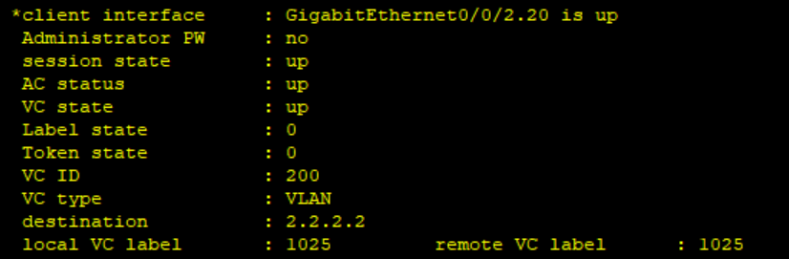
This chapter presented the design and implementation of the proposed MPLS L2VPN solution within the Huawei eNSP simulation environment. The architecture was built around two PE routers and four CE routers interconnected through an MPLS backbone supporting OSPF, MPLS, LDP, MPLS-TE, FRR, and Martini VLL technologies.

The implementation followed a structured layered approach: OSPF was deployed for core routing, MPLS and LDP for label switching, MPLS-TE for constraint-based traffic engineering, FRR for fast recovery, and Martini VLL for Layer 2 pseudowire connectivity.

The functionality and behavior of the implemented network are evaluated in the following chapter through experimental verification and failure recovery testing.

6. Experimental Results and Verification
The practical implementation of the proposed MPLS L2VPN network was verified through a series of experiments conducted within the Huawei eNSP simulation environment. The objective of these experiments was to validate the successful operation of the Martini-based Layer 2 VPN service, MPLS Traffic Engineering (MPLS-TE) tunnels, and Fast Reroute (FRR) protection mechanisms. Connectivity tests, tunnel status verification, and failure recovery scenarios were performed to evaluate the functionality, reliability, and resiliency of the implemented network. A summary of the test scenarios and their outcomes is presented in table 3.

Table3 Actual Lab result

Test Scenario | Expected Result | Actual Result
Martini VLL Pseudowire Establishment | Pseudowire State UP | Successful
MPLS-TE Tunnel Establishment | Tunnel State UP | Successful
End-to-End Connectivity | Customer Sites Reachable | Successful
FRR Protection Activation | Automatic Switchover | Successful
Service Continuity During Failure | Connectivity Maintained | Successful
6.1 Verification of Martini L2VPN Service
The first experiment was conducted to verify the successful establishment of the Martini-based Virtual Leased Line (VLL) service between the customer sites. The status of the Layer 2 pseudowires was examined using MPLS L2VPN verification

commands on the Provider Edge routers. The results confirmed that the configured Virtual Circuit (VC) instances were successfully established and remained in the operational state.

Figure 4. Verification of Martini-Based MPLS L2VPN Pseudowire Status

The verification output of the MPLS L2VPN pseudowire status between the Provider Edge routers is shown in Figure 4.
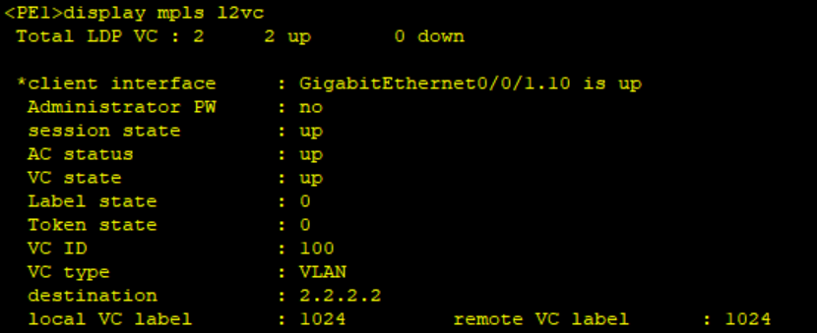

The output confirms that both configured virtual circuits (VC 100 and VC 200) are in the UP state, indicating successful pseudowire establishment and proper Layer 2 connectivity between the corresponding customer sites.

The end-to-end connectivity between the customer sites was verified using an ICMP ping test between CE1 and CE2. The test results are shown in Figure 5.
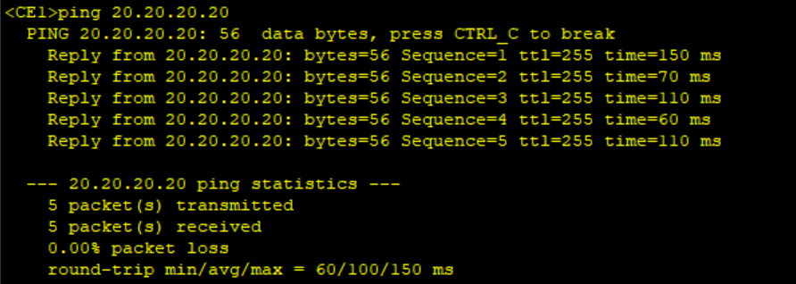

Figure 5. End-to-End Connectivity Verification Between CE1 and CE2

The successful ping replies confirm that the Martini-based MPLS L2VPN service provides transparent Layer 2 connectivity between the customer sites and allows reliable communication across the MPLS backbone.
The operational status of the MPLS Traffic Engineering (MPLS-TE) tunnel was verified on PE1 to ensure successful tunnel establishment between the Provider Edge routers. The verification output is shown in Figure 6.
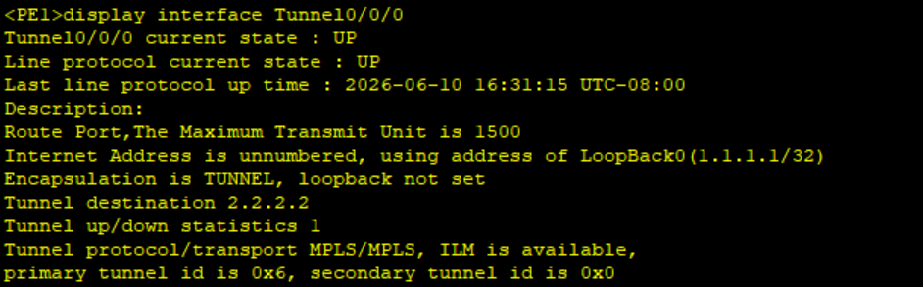

Figure 6. Verification of MPLS-TE Tunnel Establishment

The output confirms that Tunnel0/0/0 and its associated line protocol are in the UP state, indicating successful establishment and operation of the MPLS-TE tunnel between PE1 and PE2. This verifies that the MPLS-TE infrastructure is functioning correctly and provides the required forwarding path for L2VPN traffic across the MPLS backbone.To evaluate the effectiveness of the Fast Reroute (FRR) mechanism, the primary link between PE1 and PE2 was intentionally disabled while continuous connectivity testing was performed between CE1 and CE2. The observed results are shown in Figure 7.
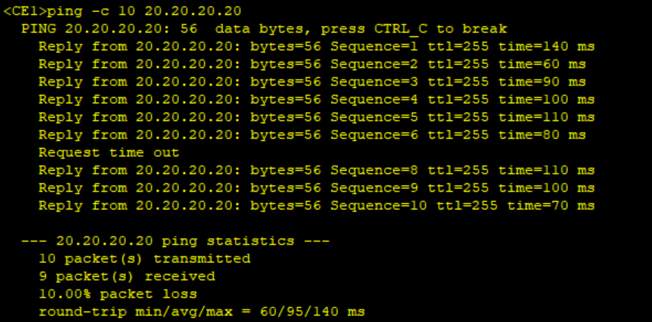
Figure 7. Fast Reroute (FRR) Protection and Service Continuity

The results show that only a single packet was lost during the failure of the primary link, after which connectivity was automatically restored through the backup path. This demonstrates the effectiveness of the FRR mechanism in maintaining service continuity while minimizing service disruption during link failures.

6.2 Discussion of Results
The experimental results collectively confirm that the proposed Martini-based MPLS L2VPN architecture achieves its core design objectives. The successful establishment of both pseudowires (VC 100 and VC 200) in the UP state, combined with zero packet loss under normal operating conditions, validates the reliability of LDP-based signaling in distributing VC labels and maintaining bidirectional pseudowire forwarding between PE1 and PE2. These findings are consistent with earlier work by Kim et al. (2006), who demonstrated that Martini-mode VLL can effectively deliver transparent Layer 2 connectivity in provider network environments.

The MPLS-TE tunnel verification confirmed that RSVP-TE signaling successfully established an explicit forwarding path between the two Provider Edge routers, routing traffic through the designated primary link (GE0/0/0) rather than relying on shortest-path routing alone. This level of traffic control directly addresses the limitations of traditional Layer 2 connectivity approaches such as leased lines and Frame Relay, which lack policy-based path selection and dynamic adaptability. Furthermore, CSPF-based path computation ensures that L2VPN traffic is forwarded along routes that satisfy defined bandwidth constraints, a capability not inherently provided by standard LDP-based forwarding.

The FRR experiment yielded the most operationally significant result: only a single packet was lost during the deliberate failure of the primary link, after which connectivity was automatically restored through the backup path (GE0/0/3). This near-instantaneous recovery demonstrates the advantage of pre-computed backup paths over reactive convergence mechanisms such as OSPF reconvergence, which typically requires several seconds to restore forwarding after topology changes. This result aligns with the sub-50-millisecond recovery targets commonly cited in MPLS-TE literature and confirms that FRR protection is both practical and effective within the simulation environment.
Compared with traditional OSPF-based recovery, which relies on routing protocol reconvergence after a topology change, the implemented Fast Reroute (FRR) mechanism provides local protection and immediate traffic redirection through a pre-established backup path. As a result, service interruption is significantly reduced, as demonstrated by the loss of only a single packet during the simulated link failure. This highlights the operational advantage of FRR in maintaining service continuity for MPLS-based Layer 2 VPN deployments.From a comparative perspective, the proposed integrated solution — combining Martini VLL, MPLS-TE, and FRR within a single architecture — extends beyond the scope of most prior studies. While Raza et al. (2014) addressed QoS provisioning for L2VPN and Li et al. (2012) focused on security enhancements, neither study evaluated traffic engineering and fast recovery in a unified framework. This work therefore provides a more comprehensive verification model that demonstrates how these mechanisms interact within a realistic provider topology.Nevertheless, certain limitations should be acknowledged. The experiments were conducted entirely within a software-based simulation environment (Huawei eNSP), and results may differ under real hardware conditions, particularly regarding FRR timing accuracy and LDP stability under high traffic loads. Additionally, the topology is limited to two PE routers and four CE devices, which does not fully represent scalability challenges in large multi-PE deployments. Future work should include performance evaluation under traffic stress conditions, comparison with Kompella-based implementations, and validation on physical Huawei networking equipment.
7. Conclusion
This study presented the design, implementation, and evaluation of a Martini-based MPLS Layer 2 Virtual Private Network (L2VPN) architecture, enhanced with MPLS Traffic Engineering (MPLS-TE) and Fast Reroute (FRR) mechanisms, within a Huawei eNSP simulation environment. The proposed solution aimed to deliver transparent, reliable, and resilient Layer 2 connectivity between geographically distributed customer sites while ensuring service continuity under link failure conditions.
The experimental evaluation confirmed that the proposed architecture successfully achieved all defined objectives. Martini-based pseudowires were successfully established using LDP signaling, enabling transparent Layer 2 communication between the Almadar and Libyana branch sites. End-to-end connectivity tests validated that the MPLS core operated transparently from the perspective of the Customer Edge devices.MPLS-TE tunnels were successfully established using RSVP-TE signaling and explicit path definitions, providing controlled and optimized traffic forwarding across the provider backbone. Most notably, the FRR mechanism demonstrated near-instantaneous recovery during a simulated primary link failure, maintaining service continuity with minimal packet loss and confirming high network availability.From a research contribution perspective, this study extends beyond prior work by presenting a unified implementation and verification framework that integrates Martini VLL, MPLS-TE, and FRR within a single coherent architecture. While earlier studies addressed these mechanisms in isolation — focusing on architectural frameworks, QoS provisioning, or security enhancements — this work demonstrates that their combined deployment produces a measurably more resilient and controllable Layer 2 service, confirming its suitability for enterprise and service-provider environments requiring stable and high-performance connectivity.It should be acknowledged, however, that the evaluation was conducted entirely within a controlled simulation environment, which may not fully replicate the timing precision and hardware behavior of real-world deployments. Future work should therefore focus on validating the proposed design on physical Huawei networking infrastructure, evaluating scalability under high traffic loads and multi-PE configurations, comparing Martini-based implementations with Kompella-based L2VPN approaches, and exploring integration with advanced QoS policies and IPv6-enabled network environments.
8. Recommendations
Future work should prioritize validating the proposed design on physical Huawei networking equipment, as simulation environments may not fully capture real-world constraints such as hardware latency, interface timing, and link-state behavior under load. Performance evaluation should also be conducted under varying traffic conditions, with particular attention to measurable metrics including throughput, end-to-end delay, jitter, and packet loss rates across different traffic volumes and pseudowire configurations.

A comparative study between Martini-based and Kompella-based L2VPN implementations would provide valuable insight into the trade-offs between simplicity and scalability in service-provider deployments. Furthermore, the integration of advanced Quality of Service (QoS) mechanisms — such as traffic classification, queuing policies, and bandwidth reservation — would strengthen the proposed architecture's ability to support differentiated service levels for enterprise customers.

From a security perspective, future implementations should investigate the incorporation of control-plane protection mechanisms and data-plane encryption to address vulnerabilities inherent in MPLS-based L2VPN environments. Finally, extending the proposed design to support IPv6-enabled and cloud-connected network infrastructures would broaden its applicability in modern enterprise and next-generation service-provider environments.
9. Acknowledgments
The authors extend their sincere thanks to the AL-salam International University and the Department of Information Technology for their academic support and encouragement throughout this research. They also express their gratitude to their colleagues and reviewers for their valuable guidance and assistance, which contributed to the successful completion of this work.

11. REFERENCES
- E. Rosen and Y. Rekhter, “RFC 4664: Framework for Layer 2 Virtual Private Networks (L2VPNs),” IETF, 2006.
https://www.rfc-editor.org/rfc/rfc4664

- Cisco Systems, “MPLS Layer 2 VPNs (L2VPN) Configuration Guide,” Cisco Documentation.
https://www.cisco.com/c/en/us/support/docs/multiprotocol-label-switching-mpls/mpls/116065-technote-l2vpn-00.html

- J. Moy, “RFC 2328: OSPF Version 2,” IETF, 1998.
https://www.rfc-editor.org/rfc/rfc2328

- D. Awduche et al., “RFC 3209: RSVP-TE Extensions for Traffic Engineering,” IETF, 2001.
https://www.rfc-editor.org/rfc/rfc3209

- E. Rosen, A. Viswanathan, and R. Callon, “RFC 3031: Multiprotocol Label Switching Architecture,” IETF, 2001.
https://www.rfc-editor.org/rfc/rfc3031

- Cisco Systems, “OSPF Fundamentals,” Cisco White Paper.
https://www.cisco.com/c/en/us/support/docs/ip/open-shortest-path-first-ospf/7039-1.html

- S. Sangli et al., “RFC 4364: BGP/MPLS IP VPNs,” IETF, 2006.
https://www.rfc-editor.org/rfc/rfc4364

- Cisco Systems, “MPLS Technology Overview,” Cisco Learning Network.
https://www.cisco.com/c/en/us/products/ios-nx-os-software/mpls/index.html

- K. Kompella and Y. Rekhter, “Draft-ietf Kompella L2VPN (Historical reference),” IETF Draft.
https://datatracker.ietf.org/doc/html/draft-ietf-l2vpn-vpls-ldp

- IETF MPLS Traffic Engineering Overview (RSVP-TE + CSPF concepts), RFC 3209 + RFC 2702 concepts combined. https://www.rfc-editor.org/rfc/rfc3209

- A. J. Andersson et al., “RFC 4447: Pseudowire Setup and Maintenance Using LDP,” IETF, 2006.
https://www.rfc-editor.org/rfc/rfc4447

- IETF, “RFC 6074: Provisioning, Auto-Discovery, and Signaling in Layer 2 Virtual Private Networks (L2VPNs),” 2011.
https://www.rfc-editor.org/rfc/rfc6074
- Huawei Technologies, “MPLS L2VPN Configuration Guide,” Huawei Documentation.
https://support.huawei.com/enterprise/en/doc/EDOC1000178171

- Huawei Technologies, “MPLS Traffic Engineering Configuration Guide,” Huawei Documentation.
https://support.huawei.com/enterprise/en/doc/EDOC1100113652

