Different Transfer Learning Approaches for COVID-19 Detection and Grad-CAM-Based Severity Assessment Using Chest X-Ray and CT Images
Abubaker Benshatwan¹ , Hasan M Alqatani² , Salema M Nouri³, Ziyad M Elfaghi ⁴.
¹ ² ³ ⁴ Faculty of Computer Technology and Information, Al-Salam International University, , Benghazi, Libya
ــــــــــــــــــــــــــــــــــــــــــــــــــــــــــــــــــــــــــــــــــــــــــــــــــــــــــــــــــــــــــــــــــــــــــــــــــــــــــــــــــــــــــــــــــــــــــــــــــــــــــ

Abstract— COVID-19 detection from chest radiological images remains challenging because its imaging patterns may overlap with pneumonia and normal lung variations. This paper presents a comparative transfer learning framework for automatic COVID-19 detection and Grad-CAM-based severity assessment using chest X-ray and CT images. Three pre-trained convolutional architectures—DenseNet-201, VGG-16, and Inception-v3—were modified and evaluated on two balanced datasets, DS_X9K and DS_CT9K, each containing 9,000 images equally distributed among COVID-19, pneumonia, and normal classes. Twelve models were investigated across both imaging modalities using two strategies: frozen feature extraction with trainable classification layers, and full fine-tuning of all network parameters. The results show that full fine-tuning achieved stronger and more stable performance, reaching up to 98% test accuracy on CXR images and approximately 99% on CT images. Grad-CAM heatmaps provided interpretable visual evidence by localizing disease-related lung regions and supporting visual severity assessment.
Keywords: COVID-19, transfer learning, CXR, CT scan, Grad-CAM, severity assessment
I. INTRODUCTION
Coronavirus disease 2019 remains an important respiratory condition because its clinical and radiological manifestations can vary from mild respiratory symptoms to severe lung involvement. Although the emergency phase of the pandemic has decreased in many countries, reliable diagnostic support systems remain valuable, particularly in hospitals with limited radiology resources or high patient load. Early identification of infected cases supports triage, isolation, and monitoring, while assessing lung involvement can help clinicians understand disease progression and prioritize care.
RT-PCR is commonly used to confirm SARS-CoV-2 infection; however, it is not a complete tool for evaluating pulmonary involvement. Its performance may be affected by sampling quality, viral load, laboratory availability, cost, and processing time. Fang et al. reported that chest CT showed higher sensitivity than RT-PCR in their patient cohort, which supports the use of radiological imaging as an important complementary tool when clinical suspicion is high or laboratory results are delayed (Fang et al., 2020). Recent reviews also confirm that chest CT can support symptomatic patient assessment, although it should not replace laboratory confirmation because specificity varies across studies (Garcia et al., 2024).
Chest X-ray and CT imaging provide complementary diagnostic information. Chest X-ray is fast, inexpensive, and widely available, making it suitable for screening and triage. CT imaging provides more detailed visualization of lung lesions, lesion distribution, and disease progression. COVID-19 may appear as ground-glass opacities, consolidation, bilateral lung involvement, and peripheral abnormalities. However, these findings are not fully specific to COVID-19 and may overlap with viral or bacterial pneumonia, making manual interpretation difficult, especially when radiological findings are subtle or when radiologists are under pressure (Bernheim et al., 2020; Shi et al., 2020).
Deep learning has become a powerful approach for medical image classification because convolutional neural networks can learn discriminative visual patterns directly from image data. In COVID-19 imaging research, convolutional models have been applied to CXR and CT images for binary and multiclass classification. However, training deep networks from scratch requires large labeled datasets, high computational resources, and careful control of overfitting. These requirements are difficult in medical imaging because of patient privacy, limited annotated images, differences between imaging devices, and class imbalance.
Transfer learning addresses these limitations by adapting models trained on large-scale image datasets to specialized medical imaging tasks. Instead of learning all features from the beginning, transfer learning reuses previously learned representations and fine-tunes them for a new classification problem (Pan & Yang, 2010). Recent research confirms that Equations transfer learning remains highly relevant for COVID-19 diagnosis. El Houby proposed a chest X-ray transfer-learning framework using VGG19 and EfficientNetB0, reporting 0.95 accuracy for binary classification and 0.935 for four-class classification (El Houby, 2024). Kordnoori et al. proposed a CT-based deep learning framework and reported 89.00% accuracy, 0.95 sensitivity, 0.88 specificity, and 0.92 AUC (Kordnoori et al., 2025). Lamouadene et al. showed that transfer learning models such as EfficientNet-CNN and Xception-CNN achieved 99.20% and 98.80% accuracy for radiographic pulmonary disease classification, while also emphasizing dataset diversity and representativeness as key limitations (Lamouadene et al., 2025).
Interpretability is also essential in medical image analysis. A model with high accuracy but no explanation is limited in clinical usefulness because clinicians need to verify whether the decision is based on meaningful lung abnormalities. Grad-CAM provides class-discriminative heatmaps that highlight regions contributing to the model’s prediction (Selvaraju et al., 2017). In COVID-19 imaging, Grad-CAM can help verify whether the model focuses on lung regions rather than irrelevant artifacts, and it can support visual severity assessment by showing the extent and intensity of disease-related activation.
The datasets used in this paper were adopted from the previous work of Abubaker et al. (2023), which introduced DS_X9K for CXR images and DS_CT9K for CT images. Each dataset contains 9,000 images equally distributed among COVID-19, pneumonia, and normal classes, with 3,000 images per class and an 80/20 train-test split. This paper uses these datasets to evaluate the transfer learning models.
II. PROBLEM STATEMENT
Although chest imaging is useful for supporting COVID-19 diagnosis, automatic classification remains challenging for three main reasons. First, COVID-19 radiological patterns overlap with pneumonia, especially in cases showing ground-glass opacities, consolidation, or diffuse lung involvement. This overlap increases the risk of misclassification between COVID-19 and non-COVID pneumonia.
Second, many previous studies reported high performance using small or imbalanced datasets. When COVID-19 samples are fewer than normal or pneumonia samples, models may learn dataset-specific artifacts rather than medically relevant lung patterns. Dataset diversity and representativeness remain major issues in recent pulmonary image classification research (Lamouadene et al., 2025).
Third, transfer learning strategies are not always evaluated systematically. Some studies freeze the pre-trained feature extractor and train only the classifier, while others fine-tune all network parameters. These strategies may behave differently across CXR and CT images and across architectures such as DenseNet, VGG, and Inception.
A further issue is interpretability. A high-performance model is not sufficient for medical use unless the decision can be visually inspected. Grad-CAM can help address this limitation by showing which lung regions contributed to the prediction. Therefore, the central problem addressed in this paper is the lack of a balanced, modality-aware, and interpretable comparison of transfer learning approaches for COVID-19 detection from both CXR and CT images.

III. AIMS AND OBJECTIVES
The aim of this paper is to evaluate different transfer learning approaches for automatic COVID-19 detection and Grad-CAM-based severity assessment using CXR and CT images.
1. Modify DenseNet-201, VGG-16, and Inception-v3 for three-class classification.
2. Build twelve transfer learning models: six for CXR and six for CT images.
3. Compare frozen-feature training with full-parameter fine-tuning.
4. Evaluate the models using accuracy, precision, recall, F1-score, and confusion matrices.
5. Use Grad-CAM to visually localize disease-related lung regions and support severity assessment.
IV. RESEARCH CONTRIBUTIONS
1. It presents a comparative transfer learning framework for COVID-19 detection from both CXR and CT images.
2. It evaluates twelve modified models derived from DenseNet-201, VGG-16, and Inception-v3.
3. It compares two training strategies: frozen feature extraction and full fine-tuning.
4. It uses two balanced datasets, each containing 9,000 images and three equally represented classes.
5. It integrates Grad-CAM to support interpretability and visual severity assessment.
6. It compares the proposed models with recent and classical COVID-19 imaging studies.

V. LITERATURE REVIEW
Early COVID-19 imaging studies demonstrated the feasibility of using deep convolutional models for infection detection from chest radiographs. For example, Ozturk et al. developed DarkCovidNet and reported 98.08% accuracy for binary classification and 87.02% for three-class classification using CXR images (Ozturk et al., 2020). Similarly, Wang et al. introduced COVID-Net as one of the early tailored deep convolutional models for detecting COVID-19 from CXR images (Wang et al., 2020).
Although these studies were important in establishing the potential of automated COVID-19 screening, their reported performance should be interpreted carefully because many early datasets contained a limited number of COVID-19 samples or showed a clear imbalance between COVID-19, pneumonia, and normal classes. For instance, the reviewed literature shows that several CXR studies used relatively small COVID-19 classes, such as 125 COVID-19 images in DarkCovidNet, 358 COVID-19 images in COVID-Net, and even smaller datasets in some early frameworks. Such imbalance can lead to optimistic accuracy values while reducing the ability of the model to generalize to unseen clinical data.
Transfer learning has therefore become a common solution in COVID-19 image classification because it reduces the need to train deep networks from scratch and allows pre-trained visual representations to be adapted to medical images. Architectures such as DenseNet, VGG, ResNet, Inception, Xception, and EfficientNet have been widely used for CXR and CT classification. Recent studies confirm that transfer learning remains relevant beyond the early pandemic period. El Houby used VGG19 and EfficientNetB0 for CXR-based COVID-19 classification, while Kordnoori et al. proposed a CT-based deep learning framework for COVID-19 classification. Lamouadene et al. also investigated radiographic classification of COVID-19, lung opacity, and viral pneumonia using machine learning, deep learning, and transfer learning approaches (El Houby, 2024; Kordnoori et al., 2025; Lamouadene et al., 2025). However, despite their promising results, many transfer learning studies still focus on either CXR or CT images separately, rather than evaluating both modalities within the same experimental framework.
A critical review of the literature reveals several methodological limitations. First, a large portion of previous work focused on binary classification, such as COVID-19 versus normal, which is clinically less challenging than distinguishing COVID-19 from pneumonia and normal cases. Second, some studies reported high accuracy while using datasets in which COVID-19 images were much fewer than other classes, making accuracy alone insufficient as a reliable performance indicator. Third, several studies used data augmentation to compensate for limited samples, but augmentation cannot fully replace real diversity in patient populations, imaging devices, and acquisition protocols. Fourth, few studies systematically compared two transfer learning strategies: freezing the pre-trained feature extractor versus fine-tuning all model parameters. This gap is important because the behavior of transfer learning models can vary considerably depending on whether the model is used as a fixed feature extractor or fully adapted to the target medical dataset.
CT-based studies also show strong potential but have similar limitations. Some works achieved high performance using DenseNet, ResNet, VGG, Xception, or hybrid frameworks; however, several of them relied on binary classification or relatively small CT datasets. Other studies included pneumonia as a third class, which is more clinically relevant, but still lacked balanced evaluation across both CT and CXR modalities. The reviewed project literature specifically notes that fewer studies jointly used CXR and CT images because building two sufficiently large and reliable datasets is difficult. This supports the motivation of the present paper, which uses two balanced datasets, DS_X9K and DS_CT9K, and evaluates the same transfer learning architectures across both imaging modalities.
Explainability has also become an essential requirement in medical image classification. High numerical accuracy is not sufficient if the model does not provide visual evidence supporting its decision. Grad-CAM is widely used to highlight the regions that contribute most strongly to model predictions (Selvaraju et al., 2017). In COVID-19 diagnosis, Grad-CAM can help verify whether the model focuses on lung abnormalities rather than irrelevant image artifacts. Nevertheless, in many previous studies, Grad-CAM was used only as a qualitative visualization tool without being integrated into the overall discussion of severity assessment. Therefore, the present paper combines quantitative evaluation metrics with Grad-CAM visualization to support both classification performance and interpretable severity-related analysis.
Based on this review, the main research gap can be summarized as follows: previous studies have demonstrated the usefulness of deep learning and transfer learning for COVID-19 detection, but many were limited by small or imbalanced datasets, single-modality evaluation, binary classification settings, limited comparison between training strategies, or insufficient interpretability analysis. The present paper addresses these limitations by comparing twelve modified transfer learning models derived from DenseNet-201, VGG-16, and Inception-v3 across both CXR and CT images, using balanced three-class datasets and Grad-CAM-based visual interpretation.
VI. PROPOSED METHODOLOGY
The proposed methodology consists of five stages: dataset preparation, preprocessing, model modification, training and evaluation, and Grad-CAM-based interpretation.
Two balanced datasets are used. DS_X9K contains 9,000 CXR images divided equally into COVID-19, pneumonia, and normal classes. DS_CT9K contains 9,000 CT images with the same class distribution. Each dataset contains 3,000 images per class and is divided into 80% training and 20% testing, producing 7,200 training images and 1,800 testing images for each modality. The project files state that DS_X9K was collected from multiple open sources including TCIA, CheXpert, NIH, radiology society sources, and public pneumonia/COVID-19 repositories; DS_CT9K was compiled from public CT sources including TCIA, radiology sources, COVID-CT, SARS-CoV-2 CT-scan, MosMedData, and COVID-CT-MD-related sources.
All images are resized to 224 × 224 × 3 and normalized to the range [0, 1]. Data augmentation is applied only to training images using rotation, zooming, and shearing. Testing images are not augmented to maintain unbiased evaluation. Labels are encoded into three classes: COVID-19, pneumonia, and normal.
Three pre-trained CNN architectures are selected: DenseNet-201, VGG-16, and Inception-v3. These architectures were chosen because they represent different feature-learning mechanisms: DenseNet-201 uses dense connectivity and feature reuse, VGG-16 uses a simple and deep stack of convolutional layers, and Inception-v3 extracts multi-scale features through inception modules. The dissertation explains these architectures and identifies them as state-of-the-art pre-trained CNN models suitable for transfer learning.
For each architecture, the original classification layer is removed and replaced with a new three-class classification head. Two training strategies are then used. In the first strategy, the convolutional feature extraction layers are frozen and only the newly added classification layers are trained. These models are named M-DenseNet-201, M-VGG-16, and M-Inception-v3. In the second strategy, all network parameters are trained after modification. These models are named EM-DenseNet-201, EM-VGG-16, and EM-Inception-v3. Applying these six models to both DS_X9K and DS_CT9K results in twelve transfer learning models.

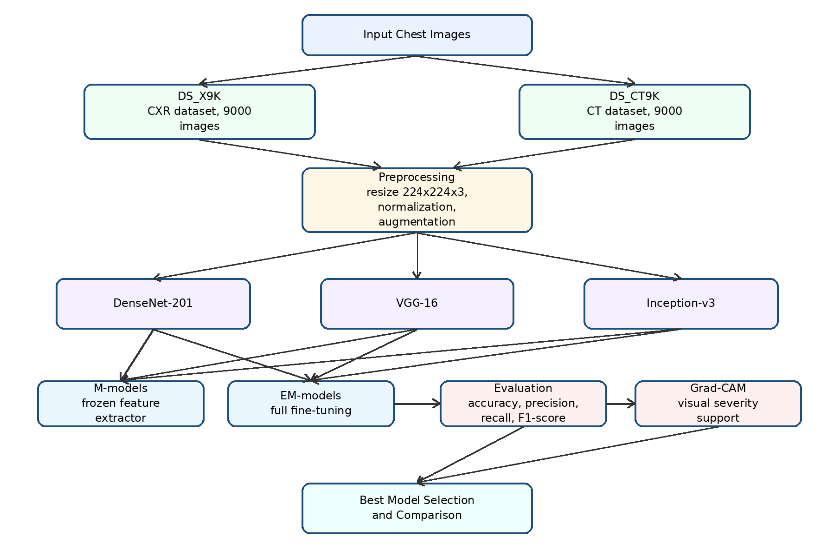
TABLE I. DATASET DESCRIPTION AND MAIN SOURCES
Dataset | Modality | Classes | Total images | Split | Main public source groups
DS_X9K | CXR | COVID-19, Pneumonia, Normal | 9,000 | 80% training / 20% testing | TCIA, CheXpert, NIH, RSNA/radiology sources, Radiopaedia, Kaggle pneumonia/COVID-19 repositories
DS_CT9K | CT | COVID-19, Pneumonia, Normal | 9,000 | 80% training / 20% testing | TCIA, radiology society sources, COVID-CT, SARS-CoV-2 CT-scan, MosMedData, COVID-CT-MD-related sources
Fig. 1. Proposed comparative transfer learning framework for COVID-19 detection and Grad-CAM-based severity assessment.
VII. EXPERIMENTAL RESULTS AND DISCUSSION
The results show that training strategy strongly affects model behavior. On the DS_X9K CXR dataset, M-DenseNet-201 achieved the best result among frozen-feature models with 94% test accuracy. M-VGG-16 achieved 90%, while M-Inception-v3 achieved 86%, indicating that frozen feature extraction was not sufficient for all architectures. When full fine-tuning was applied, performance improved. EM-DenseNet-201 achieved 98% test accuracy and the strongest F1-scores for COVID-19 and normal classes. The project discussion reports that EM-DenseNet-201 reached 100% training accuracy, 98% test accuracy, and 99% F1-score for both COVID-19 and normal classes, while pneumonia remained more difficult.
For the DS_CT9K CT dataset, the frozen-feature strategy was unstable. M-DenseNet-201 achieved 99% training accuracy but only 70% test accuracy, indicating overfitting. M-Inception-v3 also showed overfitting with 89% training accuracy and 63% test accuracy. In contrast, M-VGG-16 achieved 98% test accuracy, suggesting that VGG-16 transferred better under frozen-feature training for CT images.
The models are trained using Adam optimizer, categorical cross-entropy loss, a learning rate of 0.0001, and a batch size of 64. The training process uses callbacks such as checkpointing, early stopping, learning-rate reduction, and TensorBoard monitoring. Evaluation is performed using accuracy, precision, recall, F1-score, and confusion matrices. Grad-CAM is then applied to generate heatmaps that identify image regions contributing to model decisions. These heatmaps are used as an interpretability tool and as visual support for severity assessment. irrelevant image backgrounds. However, Grad-CAM should be interpreted as visual support for severity assessment, not as a clinically validated severity grading system unless expert severity labels are added.
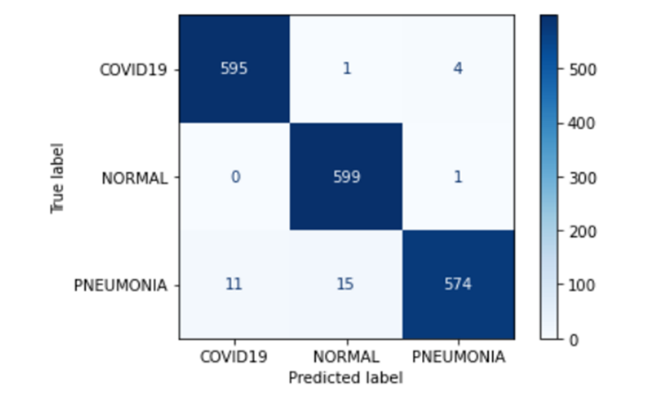
The numerical and visual evidence supporting these findings is presented in Figs. 2–6. The confusion matrix and classification report summarize the quantitative performance, while the Grad-CAM examples illustrate the image regions that contributed to the classification decision.
Fig. 2. Confusion matrix of the high-performing transfer learning model on the balanced test set.
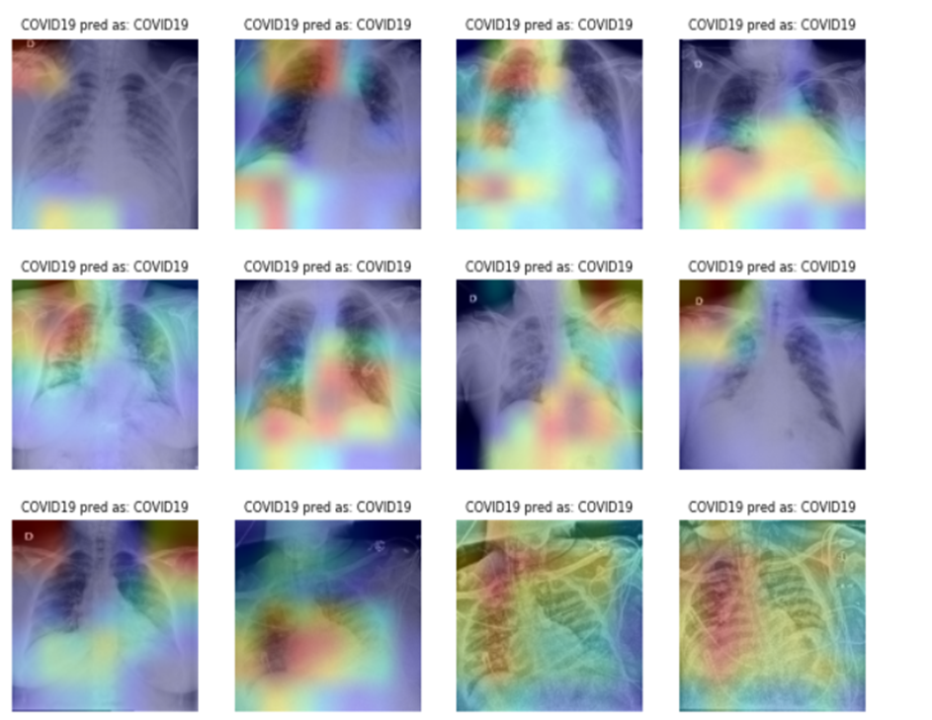
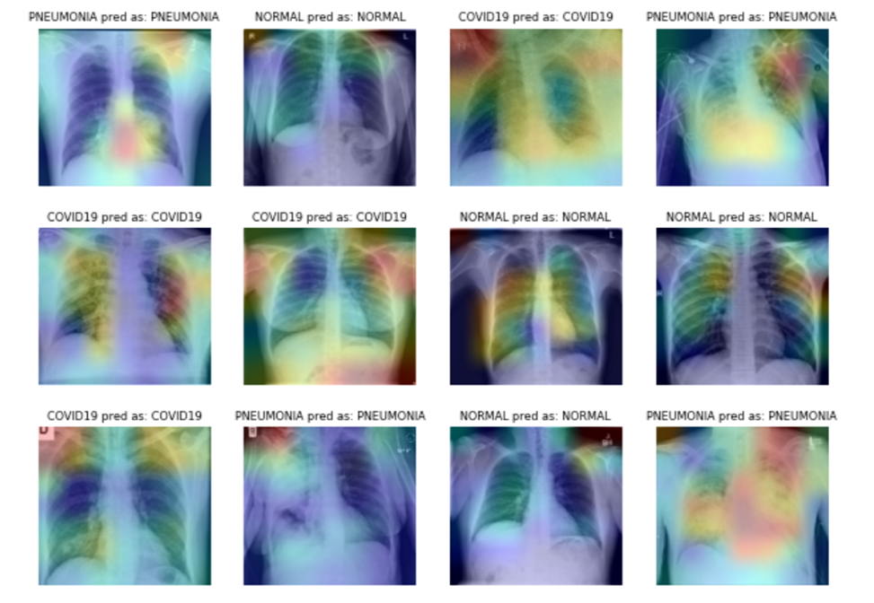
Fig. 3. Grad-CAM visualizations for representative CXR images from COVID-19, pneumonia, and normal classes.
Fig. 4. Grad-CAM visualizations for correctly classified COVID-19 CXR images.
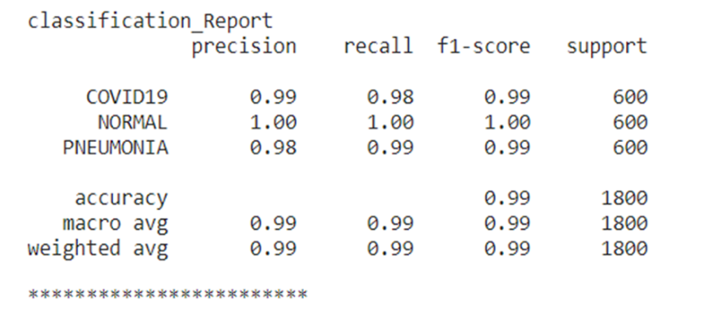
Fig. 5. Classification report of the high-performing model showing Precision recall, F1-score, and support for each class
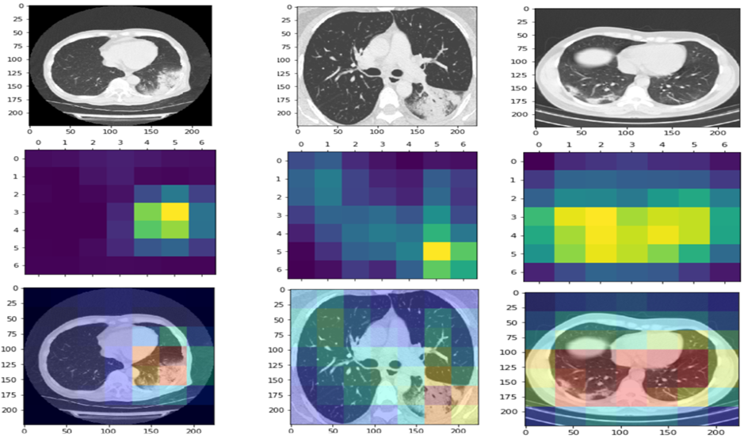
Fig. 6. Grad-CAM visualization for CT images showing original slices, activation heatmaps, and overlay maps.
TABLE II. EXPERIMENTAL RESULTS OF TH PROPOSED TRANSFER LEARNING MODELS

Dataset | Model | Strategy | Train Acc. | Test Acc. | Main observation
DS_X9K / CXR | M-DenseNet-201 | Frozen feature layers | 100% | 94% | Best frozen-feature CXR model
DS_X9K / CXR | EM-DenseNet-201 | Full fine-tuning | 100% | 98% | Best CXR model; COVID-19 and normal F1-score reached 99%
DS_X9K / CXR | M-VGG-16 | Frozen feature layers | 87% | 90% | Weaker frozen-feature CXR result
DS_X9K / CXR | EM-VGG-16 | Full fine-tuning | ~100% | ~97% | Strong full-training result
DS_X9K / CXR | M-Inception-v3 | Frozen feature layers | 90% | 86% | Weakest CXR model; high false predictions
DS_X9K / CXR | EM-Inception-v3 | Full fine-tuning | ~100% | 97% | Improved after full fine-tuning
DS_CT9K / CT | M-DenseNet-201 | Frozen feature layers | 99% | 70% | Severe overfitting
DS_CT9K / CT | EM-DenseNet-201 | Full fine-tuning | 100% | 99% | 19 incorrect predictions; normal class F1-score 100%
DS_CT9K / CT | M-VGG-16 | Frozen feature layers | 100% | 98% | Best frozen-feature CT model
DS_CT9K / CT | EM-VGG-16 | Full fine-tuning | 100% | 99% | 19 incorrect predictions; normal class fully classified
DS_CT9K / CT | M-Inception-v3 | Frozen feature layers | 89% | 63% | Severe overfitting
DS_CT9K / CT | EM-Inception-v3 | Full fine-tuning | 100% | 99% | Strong CT result; COVID-19 and pneumonia F1-score 99%

TABLE III. COMPARISON WITH PREVIOUS STUDIES
Study | Modality | Method | Dataset/Classes | Accuracy | Limitation compared with this paper
Ozturk et al. [11] | CXR | DarkCovidNet | COVID-19, pneumonia, normal | 87% three-class; 98% binary | Small COVID-19 class
Wang et al. [12] | CXR | COVID-Net | COVIDx, 3 classes | 92.6–93.3% | Imbalanced COVID-19 representation
El Houby [7] | CXR | VGG19 / EfficientNetB0 | Binary and 4-class CXR | 0.95 binary; 0.935 four-class | CXR only
Kordnoori et al. [8] | CT | Custom CT framework | Binary CT classification | 89% | Binary classification and CT only
Lamouadene et al. [9] | CXR | CNN, SVM, transfer learning | COVID-19, lung opacity, viral pneumonia, normal | up to 99.20% | CXR only; dataset diversity noted as limitation
Proposed paper | CXR + CT | 12 modified transfer learning models + Grad-CAM | Two balanced datasets, 18,000 images total | 98% CXR; 99% CT | Needs external hospital validation

VIII. SCOPE AND LIMITATIONS
The scope of this paper is limited to three-class image-level classification of COVID-19, pneumonia, and normal cases using CXR and CT images. The paper focuses on transfer learning using DenseNet-201, VGG-16, and Inception-v3, and uses Grad-CAM for visual interpretation and severity-related assessment.
The main limitation is that the datasets were compiled from public sources rather than collected prospectively from a single hospital. Although both datasets are balanced, variations in imaging protocols, patient populations, image quality, and acquisition devices may affect generalization. Another limitation is that Grad-CAM provides visual evidence of disease-related activation, but it does not provide clinically validated severity grades such as mild, moderate, and severe unless expert severity annotations are added. Finally, the evaluation is image-level rather than patient-level, so external clinical validation is required before real deployment.
IX. CONCLUSION AND FUTURE WORK
This paper presented a comparative transfer learning framework for automatic COVID-19 detection and Grad-CAM-based severity assessment using CXR and CT images. Three pre-trained convolutional architectures—DenseNet-201, VGG-16, and Inception-v3—were modified and evaluated using two training strategies: frozen feature extraction and full fine-tuning. In total, twelve transfer learning models were investigated across two balanced datasets.
The results show that full fine-tuning generally outperformed frozen-feature training. For CXR images, EM-DenseNet-201 achieved the strongest overall performance, while for CT images, the fully fine-tuned models achieved approximately 99% test accuracy. The findings also show that pneumonia remains the most challenging class because of visual overlap with COVID-19. Grad-CAM improved model interpretability by highlighting lung regions associated with disease patterns and supporting visual severity assessment.
Future work should validate the proposed models on external hospital datasets, perform patient-level evaluation, and include radiologist-reviewed severity labels. Future studies may also integrate lung segmentation before classification, compare ensemble strategies, and develop a clinically validated severity grading system based on expert annotations and Grad-CAM localization.
REFERENCES
Ai, T., Yang, Z., Hou, H., Zhan, C., Chen, C., Lv, W., Tao, Q., Sun, Z., & Xia, L. (2020). Correlation of chest CT and RT-PCR testing for coronavirus disease 2019 in China: A report of 1014 cases. Radiology, 296(2), E32–E40.
Ben shatwan, A. (2023). Using deep learning approaches for the automatic detection of COVID-19 and assessing disease severity through chest CXR and CT scan image processing. In 2023 IEEE 3rd International Maghreb Meeting of the Conference on Sciences and Techniques of Automatic Control and Computer Engineering (MI-STA) (pp. 235–241). IEEE.
Bernheim, A., Mei, X., Huang, M., Yang, Y., Fayad, Z. A., Zhang, N., Diao, K., Lin, B., Zhu, X., Li, K., Li, S., Shan, H., Jacobi, A., & Chung, M. (2020). Chest CT findings in coronavirus disease-19: Relationship to duration of infection. Radiology, 295(3), 685–691.
Clark, K., Vendt, B., Smith, K., Freymann, J., Kirby, J., Koppel, P., Moore, S., Phillips, S., Maffitt, D., Pringle, M., Tarbox, L., & Prior, F. (2013). The Cancer Imaging Archive: Maintaining and operating a public information repository. Journal of Digital Imaging, 26, 1045–1057.
El Houby, E. M. F. (2024). COVID-19 detection from chest X-ray images using transfer learning. Scientific Reports, 14, 11639.
Fang, Y., Zhang, H., Xie, J., Lin, M., Ying, L., Pang, P., & Ji, W. (2020). Sensitivity of chest CT for COVID-19: Comparison to RT-PCR. Radiology, 296(2), E115–E117.
Garcia, A., et al. (2024). A literature review on the relative diagnostic accuracy of chest CT scans versus RT-PCR testing for COVID-19 diagnosis. Tomography, 10(6).
Huang, G., Liu, Z., Van Der Maaten, L., & Weinberger, K. Q. (2017). Densely connected convolutional networks. In Proceedings of the IEEE Conference on Computer Vision and Pattern Recognition (pp. 4700–4708).
Irvin, J., Rajpurkar, P., Ko, M., Yu, Y., Ciurea-Ilcus, S., Chute, C., Marklund, H., Haghgoo, B., Ball, R., Shpanskaya, K., Seekins, J., Mong, D. A., Halabi, S. S., Sandberg, J. K., Jones, R., Larson, D. B., Langlotz, C. P., Patel, B. N., Lungren, M. P., & Ng, A. Y. (2019). CheXpert: A large chest radiograph dataset with uncertainty labels and expert comparison. Proceedings of the AAAI Conference on Artificial Intelligence, 33(1), 590–597.
Jaiswal, A., Gianchandani, N., Singh, D., Kumar, V., & Kaur, M. (2020). Classification of the COVID-19 infected patients using DenseNet201 based deep transfer learning. Journal of Biomolecular Structure and Dynamics.
Kassani, S. H., Kassani, P. H., Wesolowski, M. J., Schneider, K. A., & Deters, R. (2021). Automatic detection of coronavirus disease (COVID-19) in X-ray and CT images: A machine learning-based approach. Biocybernetics and Biomedical Engineering, 41(3), 867–879.
Kermany, D. S., Goldbaum, M., Cai, W., Valentim, C. C. S., Liang, H., Baxter, S. L., McKeown, A., Yang, G., Wu, X., Yan, F., Dong, J., Prasadha, M. K., Pei, J., Ting, M. Y. L., Zhu, J., Li, C., Hewett, S., Dong, J., Ziyar, I., ... Zhang, K. (2018). Identifying medical diagnoses and treatable diseases by image-based deep learning. Cell, 172(5), 1122–1131.
Ko, H., Chung, H., Kang, W. S., Kim, K. W., Shin, Y., Kang, S. J., Lee, J. H., Kim, Y. J., Kim, N. Y., Jung, H., & Lee, J. (2021). COVID-19 pneumonia diagnosis using a simple 2D deep learning framework with a single chest CT image. Journal of Medical Internet Research, 22(6), e19569.
Kordnoori, S., Sabeti, M., Mostafaei, H., & Banihashemi, S. S. A. (2025). A deep learning framework for accurate COVID-19 classification in CT-scan images. Machine Learning with Applications, 19, 100628.
Lamouadene, H., El Kassaoui, M., El Yadari, M., El Kenz, A., Benyoussef, A., El Moutaouakil, A., & Mounkachi, O. (2025). Detection of COVID-19, lung opacity, and viral pneumonia via X-ray using machine learning and deep learning. Computers in Biology and Medicine, 190, 110131.
Morozov, S. P., Andreychenko, A. E., Pavlov, N. A., Vladzymyrskyy, A. V., Ledikhova, N. V., Gombolevskiy, V. A., Blokhin, I. A., Gelezhe, P. B., Gonchar, A. V., & Chernina, V. Y. (2020). MosMedData: Chest CT scans with COVID-19 related findings dataset. arXiv preprint arXiv:2005.06465.
Ozturk, T., Talo, M., Yildirim, E. A., Baloglu, U. B., Yildirim, O., & Acharya, U. R. (2020). Automated detection of COVID-19 cases using deep neural networks with X-ray images. Computers in Biology and Medicine, 121, 103792.
Pan, S. J., & Yang, Q. (2010). A survey on transfer learning. IEEE Transactions on Knowledge and Data Engineering, 22(10), 1345–1359.
Selvaraju, R. R., Cogswell, M., Das, A., Vedantam, R., Parikh, D., & Batra, D. (2017). Grad-CAM: Visual explanations from deep networks via gradient-based localization. In Proceedings of the IEEE International Conference on Computer Vision (pp. 618–626).
Shi, H., Han, X., Jiang, N., Cao, Y., Alwalid, O., Gu, J., Fan, Y., & Zheng, C. (2020). Radiological findings from 81 patients with COVID-19 pneumonia in Wuhan, China: A descriptive study. The Lancet Infectious Diseases, 20(4), 425–434.
Simonyan, K., & Zisserman, A. (2015). Very deep convolutional networks for large-scale image recognition. International Conference on Learning Representations.
Soares, E., Angelov, P., Biaso, S., Froes, M. H., & Abe, D. K. (2020). SARS-CoV-2 CT-scan dataset: A large dataset of real patients CT scans for SARS-CoV-2 identification. medRxiv.
Szegedy, C., Vanhoucke, V., Ioffe, S., Shlens, J., & Wojna, Z. (2016). Rethinking the Inception architecture for computer vision. In Proceedings of the IEEE Conference on Computer Vision and Pattern Recognition (pp. 2818–2826).
Wang, L., Lin, Z. Q., & Wong, A. (2020). COVID-Net: A tailored deep convolutional neural network design for detection of COVID-19 cases from chest X-ray images. Scientific Reports, 10, 19549.
Zhao, J., Zhang, Y., He, X., & Xie, P. (2020). COVID-CT-Dataset: A CT scan dataset about COVID-19. arXiv preprint arXiv:2003.13865.

