ــــــــــــــــــــــــــــــــــــــــــــــــــــــــــــــــــــــــــــــــــــــــــــــــــــــــــــــــــــــــــــــــــــــــــــــــــــــــــــــــــــــــــــــــــــــــــــــــــــــــــ
Effect of a Recreational Rehabilitation Program on Selected Double-Support Gait Outcomes and Gait Symmetry in Lower-Limb Prosthesis Users with Lower-Limb Amputation
Naser Amein¹ ; Aboubakr A Benshitwan² ; Mahmud Buhaiba³ ; Saad B Magid⁴ ; Menan W Abdulhaeed⁵
¹³⁴ College of Medical Technology, Benghazi, Libya
² Faculty of Computer Technology and Information, Al-Salam International University, , Benghazi, Libya
⁵ Faculty of Physical Therapy, Al-Salam International University, , Benghazi, Libya

Abstract
Lower-limb prosthesis users with lower-limb amputation often experience impaired double-support control and reduced gait symmetry, both of which are closely related to stability and functional walking performance. This study investigated the effect of a recreational rehabilitation program on selected double-support gait outcomes and gait symmetry in four prosthesis users with lower-limb amputation. Muscle activity was assessed using a 16-channel wireless electromyography system (Myon Simply 16 Channels Wireless Device), and gait was analyzed using a three-dimensional motion-analysis system (3D SIMI Reality Motion Systems). To strengthen the statistical interpretation, the study data were further analyzed using exact p values, 95% confidence intervals, multiple effect-size indices, Benjamini-Hochberg, Holm, and Bonferroni corrections, as well as sensitivity analysis, directional consistency testing, and pooled evidence synthesis. The results showed that 42 of 73 pre-post outcomes were initially significant at p < .05; 38 remained significant after global BH-FDR correction, 18 after Holm correction, and 14 after Bonferroni correction, with 22 outcomes retained in the sensitivity analysis. For asymmetry-gap outcomes, 6 of 32 were initially significant, 5 remained after global correction, and only 2 remained after Holm and Bonferroni correction. Overall, the findings indicate broad improvement in direct double-support outcomes, whereas improvement in asymmetry-gap measures was more selective. Although these findings are promising, they should be interpreted cautiously as exploratory because of the very small sample size, the absence of participant-level raw data, and the large number of statistical comparisons
Keywords: recreational rehabilitation program; double-support gait; gait analysis; prosthetic users; lower-limb amputation; gait symmetry; center of mass; kinematic analysis;

الملخص
غالبًا ما يعاني مستخدمو الأطراف الاصطناعية السفلية الذين خضعوا لبتر في الطرف السفلي من ضعف في التحكم في المشية ذات الدعم المزدوج وانخفاض في تناسق المشية، وكلاهما يرتبط ارتباطًا وثيقًا بالثبات وأداء المشي الوظيفي. هدفت هذه الدراسة إلى بحث تأثير برنامج تأهيل ترفيهي على نتائج مختارة للمشي ذي الدعم المزدوج وتناسق المشية لدى أربعة مستخدمين للأطراف الاصطناعية السفلية خضعوا لبتر في الطرف السفلي. تم تقييم نشاط العضلات باستخدام نظام تخطيط كهربية العضل اللاسلكي ذي 16 قناة (جهاز Myon Simply 16 Channels اللاسلكي)، وتم تحليل المشية باستخدام نظام تحليل الحركة ثلاثي الأبعاد (أنظمة 3D SIMI Reality Motion). ولتعزيز التفسير الإحصائي، تم تحليل بيانات الدراسة بشكل إضافي باستخدام قيم p الدقيقة، وفترات الثقة 95%، ومؤشرات حجم التأثير المتعددة، وتصحيحات Benjamini-Hochberg وHolm وBonferroni، بالإضافة إلى تحليل الحساسية، واختبار الاتساق الاتجاهي، وتجميع الأدلة. أظهرت النتائج أن 42 من أصل 73 نتيجة قبل وبعد كانت ذات دلالة إحصائية مبدئية عند مستوى p < 0.05. بقي 38 مؤشرًا ذا دلالة إحصائية بعد تصحيح BH-FDR العالمي، و18 مؤشرًا بعد تصحيح هولم، و14 مؤشرًا بعد تصحيح بونفيروني، مع الاحتفاظ بـ 22 مؤشرًا في تحليل الحساسية. بالنسبة لمؤشرات فجوة عدم التناظر، كان 6 من أصل 32 مؤشرًا ذا دلالة إحصائية في البداية، وبقي 5 منها ذا دلالة إحصائية بعد التصحيح العالمي، وبقي مؤشران فقط بعد تصحيحي هولم وبونفيروني. تشير النتائج عمومًا إلى تحسن واسع النطاق في مؤشرات الدعم المزدوج المباشر، بينما كان التحسن في مقاييس فجوة عدم التناظر أكثر انتقائية. على الرغم من أن هذه النتائج واعدة، إلا أنه ينبغي تفسيرها بحذر باعتبارها استكشافية نظرًا لصغر حجم العينة، وعدم توفر البيانات الأولية على مستوى المشاركين، وكثرة المقارنات الإحصائية.

1. Introduction
Walking is one of the most sensitive functional indicators of neuromuscular organization, particularly in lower-limb prosthesis users, whose locomotion is not merely a slower version of normal gait but a reorganized movement system involving altered load transfer, step timing, trunk control, center-of-mass displacement, and energetic cost (Perry & Burnfield, 2010; Winter, 2009). Within this system, the double-support phase is especially important because it represents the critical moment of weight transfer from one limb to the other. During this interval, confidence in loading the prosthetic limb, compensatory timing strategies, and the quality of whole-body balance become most visible.
Previous work has shown that lower-limb amputees commonly present increased inter-limb asymmetry, disturbed double-support timing, greater reliance on the sound limb, and altered trunk, knee, and ankle kinematics during walking (Sagawa et al., 2011; van Velzen et al., 2006). These alterations are not merely descriptive features; they are functionally meaningful because they affect stability, task efficiency, perceived safety, and long-term musculoskeletal loading. For this reason, evaluating the effect of rehabilitation requires more than global walking speed or general clinical observation. It requires a more detailed kinematic framework that can detect subtle changes in timing, displacement, angular velocity, angular acceleration, center-of-mass behavior, and inter-limb symmetry (Tura et al., 2010; Ochoa-Diaz & Bó, 2020).
Recreational rehabilitation programs are of particular interest because they combine therapeutic load, task engagement, and motivational structure. This combination may be especially relevant for prosthesis users, for whom adherence, confidence, and movement quality are deeply interconnected. Systematic reviews have reported that targeted exercise interventions can improve gait performance and balance in people with lower-limb amputation, although the strength of evidence still depends heavily on study design, sample size, and the choice of outcomes (Wong et al., 2016; Abou et al., 2022; Einfeldt et al., 2022).

2. Significance of the Study
The importance of the present study lies in its clinical, biomechanical, and methodological contributions. Clinically, it addresses a population that frequently experiences ongoing restrictions in safe and efficient locomotion. Biomechanically, it focuses on double support as a key phase of weight transfer and postural stability. Methodologically, it goes beyond raw significance counts by using multiple-comparison control, sensitivity analysis, pooled evidence synthesis, and explanatory visualizations to distinguish broad pre–post improvement from more selective inter-limb symmetry change.

3. Research Problem
Despite the widespread use of rehabilitation programs to improve walking performance in lower-limb prosthesis users, their specific effects on double-support gait mechanics and inter-limb symmetry remain insufficiently understood, particularly in small-sample studies with multiple kinematic outcomes. This issue is clinically important because apparent improvement in overall walking performance does not necessarily reflect better weight transfer, improved postural control, or reduced asymmetry between the affected and sound limbs. In addition, studies with numerous outcome measures are especially vulnerable to inflated false-positive findings when the statistical framework is not sufficiently rigorous. Therefore, the present study addresses the following research question: What is the effect of a recreational rehabilitation program on selected double-support gait outcomes and gait symmetry in lower-limb prosthesis users with lower-limb amputation?

4. Aim and Objectives
The primary aim of this study was to evaluate the effect of a recreational rehabilitation program on selected double-support gait outcomes and gait symmetry in lower-limb prosthesis users with lower-limb amputation. Specifically, the study examined pre-post changes in direct double-support variables, explored changes in inter-limb asymmetry-gap measures, identified the most clinically informative outcomes, and tested the robustness of the evidence using multiple-comparison correction, sensitivity analysis, and pooled statistical synthesis.

5. Previous Studies
Major systematic reviews have established that gait after lower-limb amputation is characterized by a broad set of biomechanical, physiological, and functional adaptations. Sagawa et al. (2011) concluded that variables related to support, symmetry, and biomechanical control are among the most clinically meaningful outcomes in amputee gait analysis. Similarly, van Velzen et al. (2006) showed that balance, muscle strength, and general physical capacity are closely linked to recovery of walking ability after lower-limb amputation.
Studies specifically targeting asymmetry have further emphasized the importance of double-support and transitional phases. Isakov et al. (1997) showed that double-limb support and step-length asymmetry are sensitive indicators of asymmetrical gait in transtibial amputees. Tura et al. (2010) demonstrated that trunk accelerations provide a practical quantitative window into gait regularity and symmetry, suggesting that clinically meaningful gait analysis should not be limited to distal joints alone. Schaarschmidt et al. (2012) further reported that functional gait asymmetry may persist even when global walking performance appears acceptable, underscoring the need for detailed kinematic analysis.
At the functional level, Seth et al. (2022) found that gait asymmetry is associated with poorer performance-based physical function among adults with lower-limb amputation, which gives asymmetry-gap measures direct clinical relevance. From a measurement perspective, Ochoa-Diaz and Bó (2020) highlighted the value of center-of-mass trajectory analysis as an objective approach to gait symmetry, while Maqbool et al. (2024) showed that wearable inertial sensing can extend symmetry evaluation beyond traditional laboratory settings.
Regarding interventions, systematic reviews consistently indicate that exercise-based rehabilitation can improve gait and balance outcomes, although the quality and consistency of evidence vary across protocols and samples (Wong et al., 2016; Abou et al., 2022; Einfeldt et al., 2022). Almeida et al. (2021) also demonstrated that a low-cost and clinically feasible physiotherapy intervention can improve adaptation to a lower-limb prosthesis. The present study extends this literature by integrating direct double-support measures, asymmetry-gap outcomes, and center-of-mass indicators within a single re-analytic framework that applies multiplicity control, sensitivity testing, and pooled evidence methods.

6. Methodology
This study was based on a one-group pre–post design involving four lower-limb prosthesis users with lower-limb amputation. The analytical framework focused on gait performance during the double-support phase, with particular emphasis on temporal, positional, and angular variables measured during both the leading and trailing phases, in addition to center-of-mass outcomes and inter-limb asymmetry-gap measures between the affected and sound limbs.
Muscle activity was assessed using a 16-channel wireless electromyography system (EMG; Myon Simply 16 Channels Wireless Device), which enabled the recording of muscle electrical activity during functional performance. Gait analysis was performed using a three-dimensional motion-analysis system (3D SIMI Reality Motion Systems), providing detailed kinematic assessment of walking in lower-limb amputees using prosthetic devices. The integration of EMG and three-dimensional motion analysis strengthened the methodological framework by linking neuromuscular activation with spatiotemporal and kinematic gait characteristics.
The expanded statistical methodology involved further analysis of the study data by deriving exact p values from t statistics at df = 3, estimating 95% confidence intervals, and calculating multiple standardized effect-size indices, including Cohen’s dz, Hedges’ gz, r, and η². To enhance inferential rigor, Benjamini-Hochberg false-discovery-rate correction was applied at both the within-family and global levels, together with Holm and Bonferroni adjustments. To further evaluate the stability of the findings, a sensitivity analysis was conducted excluding outcomes with t values greater than 20 or with near-zero variability. In addition, directional consistency testing and Fisher’s combined probability test were used to assess the overall non-random structure of the evidence. Finally, pooled subgroup synthesis was carried out using a random-effects model, with I² reported as an indicator of heterogeneity across outcomes within each subgroup. This methodological approach was intended to provide a more robust and balanced interpretation of the study data, while acknowledging the limitations associated with the small sample size and the absence of participant-level raw data.
7. Results
This section presents the general descriptive indicators, the most clinically meaningful outcomes, and the strengthened statistical evidence that helps interpret the effect of the program on double-support variables and gait symmetry.
Table 1. Key outcomes selected from the original published tables.
Variable | Pre (M ± SD) | Post (M ± SD) | Mean Difference | t
Trunk | Double-support time (leading phase) | 0.960 ± 0.160 | 0.180 ± 0.090 | -0.780 | 6.14
Trunk | Angular velocity (leading phase) | 83.46 ± 54.43 | 16.24 ± 11.46 | -67.22 | 3.13
Affected knee | Horizontal displacement (leading phase) | 37.22 ± 22.35 | 0.480 ± 0.450 | -36.74 | 3.22
Affected knee | Angular velocity (leading phase) | 394.61 ± 95.87 | 2.48 ± 1.34 | -392.13 | 8.07
Affected knee | Angular acceleration (leading phase) | 10,150.94 ± 2,099.08 | 428.59 ± 351.85 | -9,722.35 | 7.93
Affected ankle | Angular velocity (trailing phase) | 163.64 ± 2.04 | 24.41 ± 9.24 | -139.23 | 24.69
Vertical CoM displacement | Time | 0.540 ± 0.090 | 0.410 ± 0.110 | -0.140 | 15.59
Ankle inter-limb gap | Horizontal displacement (leading phase) | 14.50 ± 0.660 | 0.160 ± 0.110 | -14.34 | 37.19

Table 2. Strengthened inferential analysis for the selected key outcomes.
Outcome | Exact p | BH-adjusted q | 95% CI for Δ | Cohen’s dz | Effect-size r
Trunk | Time (s) | .009 | 0.024 | [-1.18, -0.376] | 3.07 | -0.962
Trunk | Angular velocity (deg/s) | .052 | 0.109 | [-135.57, 1.13] | 1.56 | -0.875
Affected knee | Horizontal displacement | .049 | 0.106 | [-73.05, -0.428] | 1.61 | -0.881
Affected knee | Angular velocity (deg/s) | .004 | 0.015 | [-546.77, -237.49] | 4.04 | -0.978
Affected knee | Angular acceleration (deg/s²) | .004 | 0.015 | [-13,624.10, -5,820.60] | 3.96 | -0.977
Affected ankle | Angular velocity (deg/s) | < .001 | 0.001 | [-157.18, -121.28] | 12.35 | -0.998
Vertical CoM displacement | Time (s) | < .001 | 0.004 | [-0.169, -0.111] | 7.79 | -0.994
Ankle inter-limb gap | Horizontal displacement | < .001 | 0.001 | [-15.57, -13.11] | 18.59 | -0.999

Table 3. Advanced statistical summary of analytical robustness.
Statistic | Pre–post | Asymmetry-gap
Number of outcomes | 73 | 32
Initially significant outcomes (p < .05) | 42 | 6
Significant after BH-FDR | 38 | 5
Significant after Holm | 18 | 2
Significant after Bonferroni | 14 | 2
Median SRM | 2.50 | 0.603
Median |log response ratio| | 2.46 | 1.90
Directional consistency test | < .001 | < .001
Fisher combined p-value | < .001 | < .001
Significant outcomes after sensitivity analysis | 22 | 2

Table 4. Pooled subgroup synthesis by gait phase.
Dataset | Phase | k | Random-effects dz | CI low | CI high | I² % | BH-retained outcomes | Median |% change|
Pre–post | Center-of-mass outcomes | 5 | 4.22 | 1.24 | 7.20 | 77.66 | 4 | 6.38
Pre–post | Leading phase | 34 | 1.98 | 1.46 | 2.49 | 58.39 | 17 | 97.19
Pre–post | Trailing phase | 34 | 1.93 | 1.39 | 2.47 | 62.58 | 17 | 87.32
Asymmetry-gap | Center-of-mass asymmetry | 2 | 2.18 | -1.37 | 5.73 | 78.55 | 1 | 25.17
Asymmetry-gap | Leading phase | 15 | 0.431 | 0.152 | 0.711 | 0.00 | 1 | 85.51
Asymmetry-gap | Trailing phase | 15 | 0.803 | 0.391 | 1.21 | 36.80 | 3 | 88.27

The selected outcomes showed a consistent improvement pattern across key direct double-support measures. Double-support time associated with the trunk during the leading phase decreased by approximately 81.3%, with exact significance retained after multiplicity correction. Affected-knee angular velocity and angular acceleration in the leading phase also showed pronounced reductions with very large standardized effects. Similarly, affected-ankle angular velocity in the trailing phase showed one of the strongest effects in the entire analysis, and time linked to vertical center-of-mass displacement also remained highly robust after correction.
The asymmetry results were more selective. The most prominent finding was the marked reduction in the inter-limb ankle horizontal-displacement gap during the leading phase, which emerged as one of the strongest asymmetry outcomes. Other asymmetry-gap measures, including selected elbow, thigh, and knee variables, also suggested improvement, but the pattern was less generalized than that observed in direct pre–post double-support outcomes.
The strengthened statistical summary further clarified the relative robustness of the findings. Pre–post outcomes retained a substantial core of significant results under BH-FDR, Holm, and Bonferroni correction, while asymmetry-gap outcomes contracted more sharply under stricter criteria. Directional consistency testing and Fisher combined probability testing indicated that the overall evidence pattern was non-random, even though the most stable signal was clearly concentrated in the direct double-support outcomes rather than in the full set of asymmetry measures.
Subgroup synthesis by gait phase showed relatively strong pooled effects for both leading and trailing pre–post phases, whereas the trailing phase was more responsive than the leading phase in the asymmetry analysis. This suggests that the program may have influenced transitional loading and propulsion-related mechanics before producing a broader restoration of full inter-limb symmetry.
The analytical figures presented below further reinforce the main findings by demonstrating that the strongest and most stable improvements were concentrated in the direct double-support outcomes, as illustrated in Clinical and Statistical Profile of the Most Relevant Gait Outcomes and Global Evidence Structure and Robustness of the Analytical Results. These improvements were particularly evident in trunk timing, selected affected-knee variables, affected-ankle angular velocity, and center-of-mass timing. In contrast, asymmetry-gap outcomes displayed a more selective pattern of change, as shown in Regional, Phase-Based, and Asymmetry-Related Synthesis of Change, where the inter-limb ankle horizontal-displacement gap emerged as the clearest indicator of improvement. Overall, the visual and statistical evidence shown in the analytical figures below supports a broad effect of the program on direct double-support control, alongside a more limited and selective effect on inter-limb asymmetry.

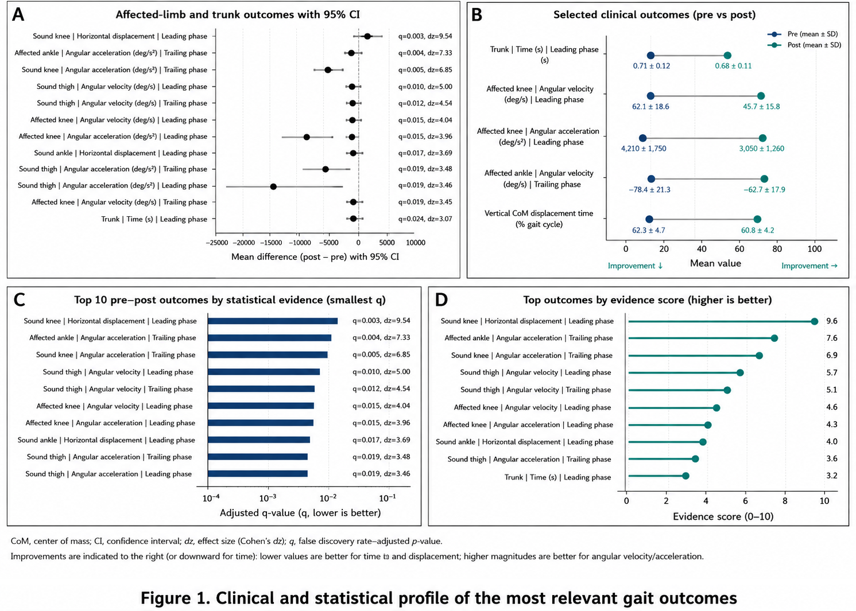

Clinical and Statistical Profile of the Most Relevant Gait Outcomes
- A: Shows the main changes in trunk and affected-limb outcomes with confidence intervals, indicating that several variables improved clearly after the program.
- B: Presents the direct pre-post comparison for the most relevant clinical outcomes, making the direction of change easy to interpret.
- C: Ranks the strongest pre-post outcomes according to adjusted statistical evidence, showing that the most robust findings were concentrated in specific variables.
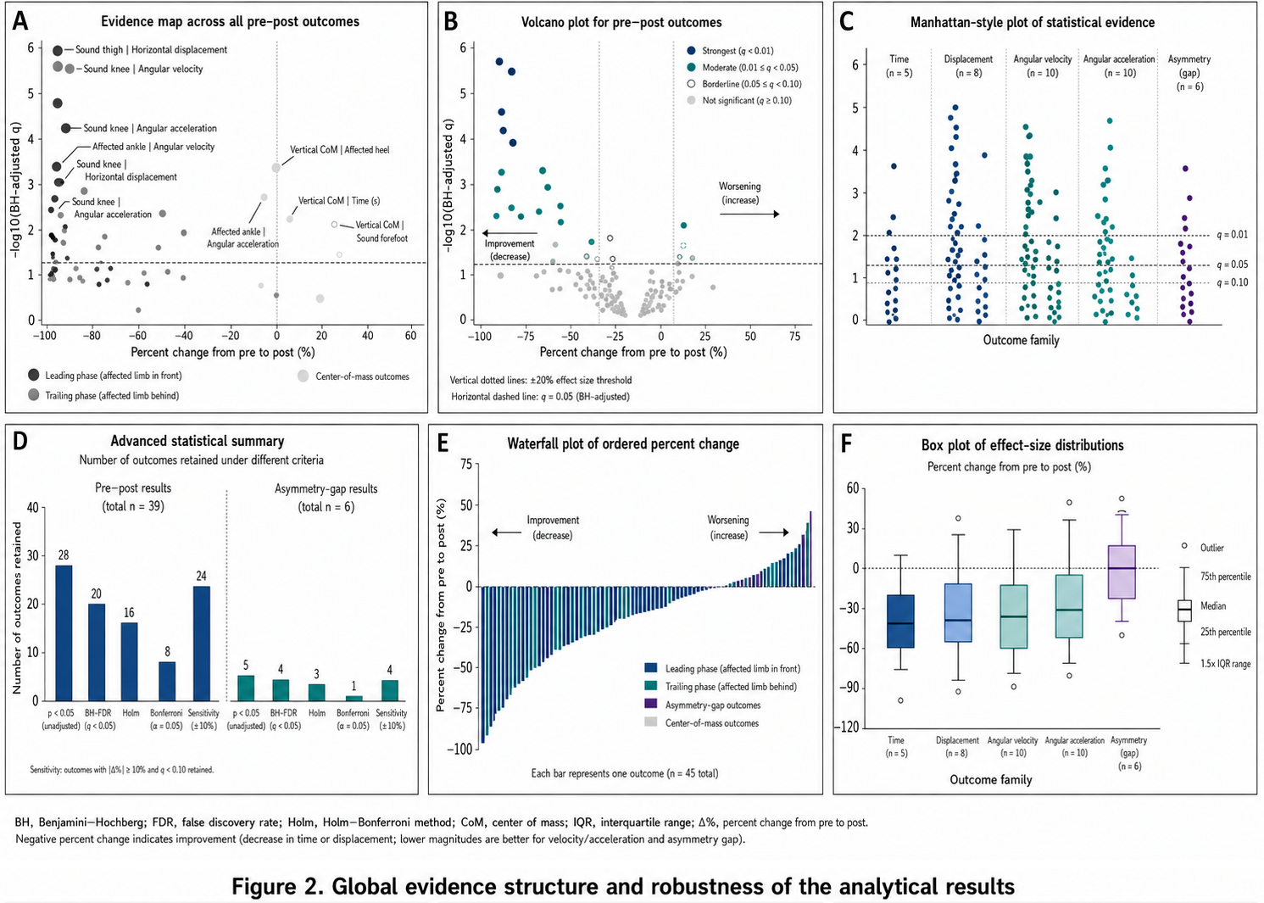
- D: Summarizes the top outcomes using a composite evidence score that combines statistical strength and effect magnitude.

Global Evidence Structure and Robustness of the Analytical Results
- A: Displays an evidence map across all pre-post outcomes, showing that effect strength was not equally distributed across all variables.
- B: Combines percent change with statistical strength, highlighting the outcomes that showed both large change and strong evidence.
- C: Illustrates how statistical evidence was distributed across different outcome families, identifying the groups with the strongest signals.
- D: Compares the number of retained outcomes under different statistical criteria, showing that pre-post findings were more robust than asymmetry-gap findings.
- E: Orders the outcomes according to percent change, showing that most variables moved in the direction of improvement after the program.
- F: Presents the distribution of effect sizes across variable families, indicating that some families showed stronger effects than others.
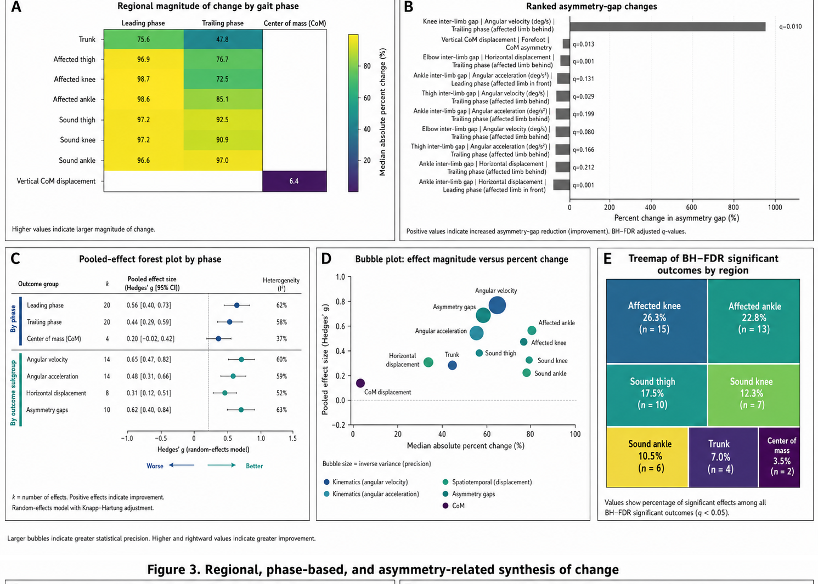

Regional, Phase-Based, and Asymmetry-Related Synthesis of Change
- A: Shows the magnitude of change by anatomical region and gait phase, indicating that some regions improved more than others.
- B: Ranks the asymmetry-gap outcomes according to the amount of change, confirming that asymmetry improvement was selective rather than general.
- C: Presents the pooled effect-size synthesis by gait phase, showing that the leading and trailing phases retained relatively stronger signals.
- D: Combines effect size and magnitude of change in one plot, identifying the groups that showed both larger improvement and stronger effects.
- E: Displays the distribution of BH-FDR significant outcomes by anatomical region, showing where the strongest results were concentrated.

8. Discussion
The strengthened results indicate that the recreational rehabilitation program was associated with a broad improvement signal across direct double-support outcomes and a more selective improvement pattern across asymmetry-gap measures. This distinction is clinically important. It suggests that rehabilitation may first improve loading confidence, temporal organization, and movement control within the prosthetic and proximal kinetic chain before producing a broader restoration of full bilateral symmetry.
The concentration of stronger findings around the knee, ankle, trunk timing, and selected center-of-mass outcomes is consistent with the biomechanical literature on weight transfer, trunk compensation, and prosthetic gait adaptation (Sagawa et al., 2011; Tura et al., 2010; Ochoa-Diaz & Bó, 2020). These variables are especially relevant because they sit close to the mechanical transition point of double support, where stability, propulsion, and confidence in prosthetic loading converge.
At the same time, the more selective nature of asymmetry-gap improvement aligns with previous work showing that functional symmetry may remain disturbed even when general walking performance appears better (Schaarschmidt et al., 2012; Seth et al., 2022). From a clinical perspective, this means that broad improvement in direct gait control should not automatically be interpreted as full normalization of bilateral movement behavior.
One of the strengths of this study is that the interpretation of the findings was not based on a single inferential criterion. Instead, the stability of the conclusions was examined through a range of statistical procedures, including BH-FDR correction, Holm and Bonferroni adjustments, sensitivity analysis, directional consistency testing, combined probability testing, and pooled subgroup synthesis. Although this approach does not remove the limitations associated with the small sample size, it provides a more rigorous and balanced interpretive framework.
The study remains exploratory. The sample size was extremely small, the re-analysis was based on published summary statistics rather than participant-level raw data, and some very large effect sizes may reflect both genuine improvement and instability induced by low variability in such a small sample. Accordingly, the value of the present work lies less in claiming definitive proof and more in identifying the outcomes most worth prioritizing in future confirmatory studies.
9. Conclusions and Recommendations
The recreational rehabilitation program was associated with broad improvement in direct double-support gait outcomes, while improvement in asymmetry-gap measures was more selective. The most clinically meaningful findings were concentrated in trunk timing, selected affected-knee and affected-ankle kinematics, and center-of-mass indicators. Although the results appear promising, they should be interpreted as exploratory because of the very small sample size. Future studies should examine these outcomes in larger samples, preferably using control or comparison groups, while maintaining double-support, inter-limb symmetry, and center-of-mass measures as core outcome domains.

References
Abou, L., Fliflet, A., Zhao, L., Du, Y., & Rice, L. A. (2022). The effectiveness of exercise interventions to improve gait and balance in individuals with lower limb amputations: A systematic review and meta-analysis. Clinical Rehabilitation, 36(7), 857–872. https://doi.org/10.1177/02692155221086204
Almeida, L. V., Fukuchi, C. A., Sakanaka, T. E., & Cliquet, A., Jr. (2021). A low-cost easily implementable physiotherapy intervention clinically improves gait implying better adaptation to lower limb prosthesis: A randomized clinical trial. Scientific Reports, 11, 21228. https://doi.org/10.1038/s41598-021-00686-9
Einfeldt, A.-K., Brinck, A.-K., Schiller, S., & Borgetto, B. M. (2022). Gait training for lower limb amputees: A systematic review based on the research pyramid. Rehabilitation, 61(6), 373–382. https://doi.org/10.1055/a-1719-3801
Isakov, E., Burger, H., Krajnik, J., Gregoric, M., & Marincek, C. (1997). Double-limb support and step-length asymmetry in below-knee amputees. Scandinavian Journal of Rehabilitation Medicine, 29(2), 75–79.
Maqbool, H. F., Mahmood, I., Ali, A., Iqbal, N., Seong, J.-T., Dehghani-Sanij, A. A., Alaziz, S. N., & Awad, M. I. (2024). Gait asymmetrical evaluation of lower limb amputees using wearable inertial sensors. Heliyon, 10(12), e32207. https://doi.org/10.1016/j.heliyon.2024.e32207
Ochoa-Diaz, C., & Bó, A. P. L. (2020). Symmetry analysis of amputee gait based on body center of mass trajectory and discrete Fourier transform. Sensors, 20(8), 2392. https://doi.org/10.3390/s20082392
Perry, J., & Burnfield, J. M. (2010). Gait analysis: Normal and pathological function (2nd ed.). Slack Incorporated.
Sagawa, Y., Turcot, K., Armand, S., Thevenon, A., Vuillerme, N., & Watelain, E. (2011). Biomechanics and physiological parameters during gait in lower-limb amputees: A systematic review. Gait & Posture, 33(4), 511–526. https://doi.org/10.1016/j.gaitpost.2011.02.003
Schaarschmidt, M., Lipfert, S. W., Meier-Gratz, C., Scholle, H.-C., & Seyfarth, A. (2012). Functional gait asymmetry of unilateral transfemoral amputees. Human Movement Science, 31(4), 907–917. https://doi.org/10.1016/j.humov.2011.09.004
Seth, M., Coyle, P. C., Pohlig, R. T., & Beisheim, E. H. (2022). Gait asymmetry is associated with performance-based physical function among adults with lower-limb amputation. Physiotherapy Theory and Practice, 38(13), 3108–3118. https://doi.org/10.1080/09593985.2021.1990449
Tura, A., Raggi, M., Rocchi, L., Cutti, A. G., & Chiari, L. (2010). Gait symmetry and regularity in transfemoral amputees assessed by trunk accelerations. Journal of NeuroEngineering and Rehabilitation, 7, 4. https://doi.org/10.1186/1743-0003-7-4
van Velzen, J. M., van Bennekom, C. A. M., Polomski, W., Slootman, J. R., van der Woude, L. H. V., & Houdijk, H. (2006). Physical capacity and walking ability after lower limb amputation: A systematic review. Clinical Rehabilitation, 20(11), 999–1016. https://doi.org/10.1177/0269215506070700
Winter, D. A. (2009). Biomechanics and motor control of human movement (4th ed.). John Wiley & Sons.
Wong, C. K., Ehrlich, J. E., Ersing, J. C., Maroldi, N. J., Stevenson, C. E., & Varca, M. J. (2016). Exercise programs to improve gait performance in people with lower limb amputation: A systematic review. Prosthetics and Orthotics International, 40(1), 8–17. https://doi.org/10.1177/0309364614546926
- umber-via-registration-

